Integration Exercises

Integration Exercise 1 (15 minutes)
  - The mozzarella cheese activity variance is computed as follows:
 | Flexible Budget | Planning Budget | Activity Variance
Number of pizzas (q) | 1,100 | 1,000
Mozzarella cheese ($2.40q) | $2,640 | $2,400 |  | $240 U
  - The mozzarella cheese spending variance is computed as follows:
 | Actual Results | Flexible Budget | Spending Variance
Number of pizzas (q) | 1,100 | 1,100
Mozzarella cheese ($2.40q) | $2,632 | $2,640 | $8 F
  - a., 3.b., and 3.c.
The materials price, quantity, and spending variances are computed as follows:
Actual Quantity of Input, at Actual Price (AQ × AP) |  | Actual Quantity of Input, at Standard Price (AQ × SP) |  | Standard Quantity Allowed for Actual Output, at Standard Price (SQ × SP)
9,400 ounces × $0.28 per ounce* = $2,632 |  | 9,400 ounces × $0.30 per ounce = $2,820 |  | 8,800 ounces** × $0.30 per ounce = $2,640
 | Materials price  variance = $188 F |  | Materials quantity variance = $180 U
 | Spending variance = $8 F

* $2,632 ÷ 9,400 ounces = $0.28 per ounce
**1,100 pizzas × 8 ounces per pizza = 8,800 ounces

Integration Exercise 2 (60 minutes)
- The total amount of product costs is computed as follows:
 | Direct materials | $ 8.00
 | Direct labor | 5.00
 | Variable manufacturing overhead | 1.00
 | Variable manufacturing cost per unit | $14.00
 | Variable manufacturing cost per unit (a) | $14.00
 | Number of units produced (b) | 25,000
 | Total variable manufacturing cost (a) × (b) |  | $350,000
 | Average fixed manufacturing overhead per unit (c) | $6.00
 | Number of units produced (d) | 25,000
 | Total fixed manufacturing cost (c) × (d) |  | 150,000
 | Total product (manufacturing) cost |  | $500,000
The total amount of period costs is computed as follows:
 | Sales commissions | $4.00
 | Variable administrative expense | 1.00
 | Variable selling and administrative per unit | $5.00
 | Variable selling and admin. per unit (a) | $5.00
 | Number of units sold (b) | 25,000
 | Total variable selling and administrative expense (a) × (b) |  | $125,000
 | Average fixed selling and administrative expense per unit ($3.50 fixed selling + $2.50 fixed administrative) (c) | $6.00
 | Number of units sold (d) | 25,000
 | Total fixed selling and administrative expense (c) × (d) |  | 150,000
 | Total period (nonmanufacturing) cost |  | $275,000
Note: The average fixed manufacturing overhead per unit ($6.00) and the average fixed selling and administrative expense per unit ($6.00) are valid for only one level of activity—25,000 units.

Integration Exercise 2 (continued)
- The variable manufacturing cost per unit produced is computed as follows:
Direct materials | $ 8.00
Direct labor | 5.00
Variable manufacturing overhead | 1.00
Variable manufacturing cost per unit | $14.00
The average fixed manufacturing cost per unit is computed as follows:
Total fixed manufacturing cost(see requirement 1) (a) | $150,000
Number of units produced (b) | 24,000
Average fixed manufacturing cost per unit produced (a) ÷ (b) | $6.25
- The variable manufacturing cost per unit produced is computed as follows:
Direct materials | $ 8.00
Direct labor | 5.00
Variable manufacturing overhead | 1.00
Variable manufacturing cost per unit | $14.00
The average fixed manufacturing cost per unit is computed as follows:
Total fixed manufacturing cost(see requirement 1) (a) | $150,000
Number of units produced (b) | 26,000
Average fixed manufacturing cost per unit produced (rounded) (a) ÷ (b) | $5.77

Integration Exercise 2 (continued)
- The total direct and indirect manufacturing costs are computed as follows:
 | Direct materials per unit | $ 8.00
 | Direct labor per unit | 5.00
 | Direct manufacturing cost per unit (a) | $13.00
 | Number of units produced (b) | 27,000
 | Total direct manufacturing cost (a) × (b) | $351,000
Variable overhead per unit (a) |  | $1.00
Number of units produced (b) |  | 27,000
Total variable overhead cost (a) × (b) |  |  | $ 27,000
Total fixed overhead (see requirement 1) |  |  | 150,000
Total indirect manufacturing cost |  |  | $177,000
- The incremental manufacturing cost is computed as follows:
 | Direct materials per unit | $ 8.00
 | Direct labor per unit | 5.00
 | Variable manufacturing overhead per unit | 1.00
 | Incremental manufacturing cost per unit produced | $14.00
- The contribution margin per unit is computed as follows:
Selling price per unit |  | $34
Variable expenses per unit:
Direct materials | $8.00
Direct labor | 5.00
Variable manufacturing overhead | 1.00
Sales commissions | 4.00
Variable administrative expense | 1.00
Total variable expenses |  | 19
Contribution margin per unit |  | $15

Integration Exercise 2 (continued)
The contribution margin ratio is computed as follows:
Contribution margin per unit (a) | $15
Selling price per unit (b) | $34
Contribution margin ratio (rounded) (a) ÷ (b) | 44.1%
- The break-even point in unit sales is computed using the equation method as follows:

Profit | = Unit CM × Q − Fixed expenses
$0 | = ($34 − $19) × Q − $300,000
$0 | = $15 × Q − $300,000
15Q | = $300,000
Q | = $300,000 ÷ $15
Q | = 20,000 units
The break-even point in dollar sales is:
20,000 units × $34 = $680,000
- The increase in net operating income is computed as follows:
Additional units sold (26,500 – 25,000) (a) | 1,500
Contribution margin per unit (b) | $15
Increase in net operating income (a) × (b) | $22,500
- The margin of safety is computed as follows:
Sales (25,000 units × $34) | $850,000
Break-even sales (20,000 units × $34) | 680,000
Margin of safety | $170,000

Integration Exercise 2 (continued)
- The first step is to prepare a contribution format income statement at a sales volume of 25,000 units as follows:
Sales (25,000 units × $34) | $850,000
Variable expenses (25,000 units × $19) | 475,000
Contribution margin | 375,000
Fixed expenses ($150,000 + $150,000) | 300,000
Net operating income | $ 75,000
The second step is to compute the degree of operating leverage as follows:
Contribution margin (a) | $375,000
Net operating income (b) | $75,000
Degree of operating leverage (a) ÷ (b) | 5.0

Integration Exercise 3 (60 minutes)
- The first step is to compute the unit product cost under absorption costing as follows:
Direct materials | $20
Direct labor | 16
Variable manufacturing overhead | 4
Fixed manufacturing overhead ($450,000 ÷ 25,000 units) | 18
Unit product cost | $58
The second step is to compute the absorption costing net operating income as follows:
Sales (20,000 units × $66 per unit) | $1,320,000
Cost of goods sold (20,000 units × $58 per unit) | 1,160,000
Gross margin | 160,000
Selling and administrative expenses [(20,000 units × $2 per unit) + $70,000] | 110,000
Net operating income | $ 50,000
- The first step is to compute the revised unit product cost under absorption costing as follows:
Direct materials | $21
Direct labor | 16
Variable manufacturing overhead | 4
Fixed manufacturing overhead ($450,000 ÷ 25,000 units) | 18
Unit product cost | $59
The second step is to compute the revised absorption costing net operating income as follows:
Sales (21,000 units × $66 per unit) | $1,386,000
Cost of goods sold (21,000 units × $59 per unit) | 1,239,000
Gross margin | 147,000
Selling and administrative expenses [(21,000 units × $2 per unit) + $70,000] | 112,000
Net operating income | $ 35,000

Integration Exercise 3 (continued)
- The unit product cost does not change; therefore, the revised absorption costing net operating income is computed as follows:
Sales (18,500 units × $67 per unit) | $1,239,500
Cost of goods sold (18,500 units × $58 per unit) | 1,073,000
Gross margin | 166,500
Selling and administrative expenses [(18,500 units × $2 per unit) + $70,000] | 107,000
Net operating income | $ 59,500
- The first step is to compute the unit product cost under variable costing as follows:
Direct materials | $20
Direct labor | 16
Variable manufacturing overhead | 4
Unit product cost | $40
The second step is to compute the variable costing net operating income as follows:
Sales (20,000 units × $66) |  | $1,320,000
Variable expenses:
Variable cost of goods sold
(20,000 units × $40 per unit) | $800,000
Variable selling and administrative (20,000 units × $2 per unit) | 40,000 | 840,000
Contribution margin |  | 480,000
Fixed expenses:
Fixed manufacturing overhead | 450,000
Fixed selling and administrative | 70,000 | 520,000
Net operating loss |  | $ (40,000)

Integration Exercise 3 (continued)
- The first step is to compute the revised unit product cost under variable costing as follows:
Direct materials | $21
Direct labor | 16
Variable manufacturing overhead | 4
Unit product cost | $41
The second step is to compute the variable costing net operating income as follows:
Sales (21,000 units × $66) |  | $1,386,000
Variable expenses:
Variable cost of goods sold
(21,000 units × $41 per unit) | $861,000
Variable selling and administrative (21,000 units × $2 per unit) | 42,000 | 903,000
Contribution margin |  | 483,000
Fixed expenses:
Fixed manufacturing overhead | 450,000
Fixed selling and administrative | 70,000 | 520,000
Net operating loss |  | $ (37,000)
- The unit product cost does not change; therefore, the revised variable costing net operating income is computed as follows:
Sales (18,500 units × $67) |  | $1,239,500
Variable expenses:
Variable cost of goods sold
(18,500 units × $40 per unit) | $740,000
Variable selling and administrative (18,500 units × $2 per unit) | 37,000 | 777,000
Contribution margin |  | 462,500
Fixed expenses:
Fixed manufacturing overhead | 450,000
Fixed selling and administrative | 70,000 | 520,000
Net operating loss |  | $ (57,500)

Integration Exercise 3 (continued)
- The break-even point in unit sales is computed as follows:
Profit | = Unit CM × Q − Fixed expenses
$0 | = ($66 − $42) × Q − $520,000
$0 | = $24 × Q − $520,000
24Q | = $520,000
Q | = $520,000 ÷ $24
Q | = 21,667 units (rounded)
Note: The variable cost per unit ($42) includes variable manufacturing costs ($40) and variable selling and administrative costs ($2).
The break-even point in dollar sales is:
21,667 units × $66 = $1,430,022
- The margin of safety is computed as follows:
Sales (20,000 units × $66) | $1,320,000
Break-even sales (21,667 units × $66) | 1,430,022
Margin of safety | $ (110,022)

Integration Exercise 4 (120 minutes+)
- Schedule of expected cash collections:
Cash sales—July ($310,000 × 20%) | $ 62,000
Collections on account receivable:
June 30 balance | 166,000
July sales ($310,000 × 80% × 30%) | 74,400
Total cash collections | $302,400
- The merchandise purchases for July are computed as follows:
Cost of goods sold ($310,000 × 60%) | $186,000
Add: Desired ending inventory ($330,000 × 60% × 20%) | 39,600
Total needs | 225,600
Deduct: Beginning inventory | 37,200
Merchandise purchases | $188,400
The expected cash disbursements for merchandise purchases is computed as follows:
June 30 accounts payable balance | $ 93,000
July purchases ($188,400 × 40%) | 75,360
Total cash disbursements | $168,360

Integration Exercise 4 (continued)

Millen Corporation
Cash Budget
For the Month of July

Beginning cash balance | $120,000
Add collections from customers (above) | 302,400
Total cash available | 422,400
Less cash disbursements:
Purchase of inventory (above) | 168,360
Selling and administrative expenses | 60,000
Total cash disbursements | 228,360
Excess of cash available over disbursements | 194,040
Financing:
Borrowing—note | 0
Repayments—note | 0
Interest | 0
Total financing | 0
Ending cash balance | $194,040

Millen Corporation
Income Statement
For the Month of July
Sales | $310,000
Cost of goods sold ($310,000 × 60%) | 186,000
Gross margin | 124,000
Selling and administrative expenses | 70,000
Net operating income | 54,000
Interest expense | 0
Net income | $ 54,000

Integration Exercise 4 (continued)

Millen Corporation
Budgeted Balance Sheet
July 31
Assets
Cash | $194,040
Accounts receivable ($310,000 × 80% ×70%) | 173,600
Inventory ($330,000 × 60% × 20%) | 39,600
Plant and equipment, net of depreciation ($554,800 – $10,000) | 544,800
Total assets | $952,040
Liabilities and Stockholders’ Equity
Accounts payable ($188,400 × 60%) | $113,040
Common stock | 586,000
Retained earnings ($199,000 + $54,000) | 253,000
Total liabilities and stockholders’ equity | $952,040

Integration Exercise 4 (continued)
- The accounts receivable turnover and inventory turnover are computed as follows:

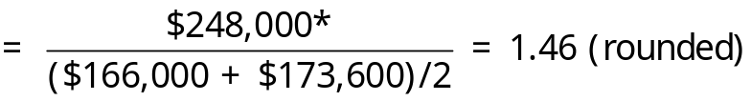
* Sales on account = $310,000 × 80% = $248,000
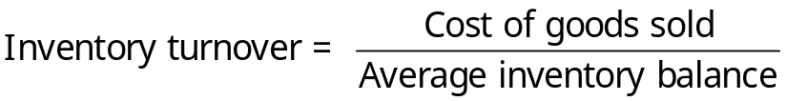
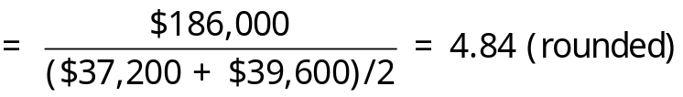
- The operating cycle is computed by calculating the average collection period and average sale period and then adding them together as follows:
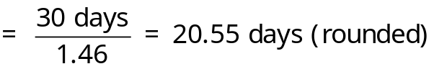
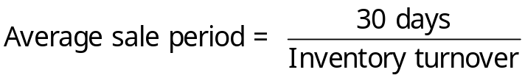
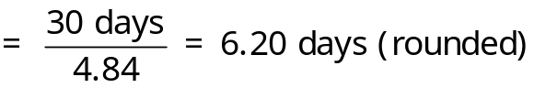

Integration Exercise 4 (continued)
- The net cash provided by operating activities is computed as follows:
Net income |  |  |  | $54,000
Adjustments to convert net income to a cash basis:
Depreciation | $10,000
Increase in accounts receivable | (7,600)
Increase in inventory | (2,400)
Increase in accounts payable | 20,040 | 20,040
Net cash provided by operating activities |  |  |  | $74,040

Integration Exercise 5 (75 minutes)
- The first step to completing the statement of cash flows is to calculate the net cash provided by operating activities as follows:
Step 1: Apply the following equation to the Accumulated Depreciation account to compute the depreciation to add back to net income:
Beginning balance – Debits + Credits = Ending balance
$480 – $9 + Credits = $640
Credits = $640 – $480 + $9
Credits = $169
Step 2: Use the guidelines from Exhibit 14-2 to analyze the changes in noncash balance sheet accounts that impact net income as follows:
 | Increase in Account Balance | Decrease in Account Balance
Current Assets
Accounts receivable |  | + 36
Inventory | – 40
Current Liabilities
Accounts payable | + 25
Accrued liabilities |  | – 11
Income taxes payable |  | – 16
Step 3: The gain on sale of equipment ($4) is subtracted from net income.

Integration Exercise 5 (continued)
The net cash provided by operating activities is computed as follows:
Net income |  | $ 42
Adjustments to convert net income to cash basis:
Depreciation | $169
Decrease in accounts receivable | 36
Increase in inventory | (40)
Increase in accounts payable | 25
Decrease in accrued liabilities | (11)
Decrease in income taxes payable | (16)
Gain on sale of equipment | (4) | 159
Net cash provided by operating activities |  | $201
The guidelines from Exhibit 14-3 can be used to analyze the changes in noncash balance sheet accounts that impact investing and financing cash flows as follows:
 | Increase in Account Balance |  | Decrease in Account Balance
Noncurrent Assets
Property, plant, and equipment |  | –63
Liabilities and Stockholders’ Equity
Bonds payable |  |  | – 130
Because Rowan did not issue any bonds during the year, the corresponding amount shown above (–130) represents the gross cash outflow pertaining to a bond retirement.

Integration Exercise 5 (continued)
Property, plant, and equipment and retained earnings require further analysis as follows:
Property, plant, and equipment:
Beginning balance + Debits – Credits = Ending balance
$1,656 + Debits – $16 = $1,719
Debits = $1,719 – $1,656 + $16
Debits = $79
The additions to property, plant, and equipment ($79) are recorded as a cash outflow and the proceeds from the sale of equipment ($11) are recorded as a cash inflow.
Retained earnings:
Beginning balance – Debits + Credits = Ending balance
$936 – Debits + $42 = $954
$42 = Debits + $18
Debits = $24
The dividend payment ($24) should be recorded as a cash outflow in the financing activities section of the statement.

Integration Exercise 5 (continued)
 |  | Rowan Company
 |  | Statement of Cash Flows
 |  | For the Year Ended December 31
 | Operating activities:
 | Net income |  |  | $ 42
 | Adjustments to convert net income to cash basis:
 | Depreciation |  | $169
 | Decrease in accounts receivable |  | 36
 | Increase in inventory |  | (40)
 | Increase in accounts payable |  | 25
 | Decrease in accrued liabilities |  | (11)
 | Decrease in income taxes payable |  | (16)
 | Gain on sale of equipment |  | (4) | 159
 | Net cash provided by operating activities |  |  | 201
 | Investing activities:
 | Proceeds from sale of equipment |  | 11
 | Additions to plant and equipment |  | (79)
 | Net cash used in investing activities |  |  | (68)
 | Financing activities:
 | Retired bonds payable |  | (130)
 | Cash dividends |  | (24)
 | Net cash used in financing activities |  |  | (154)
 | Net decrease in cash |  |  | (21)
 | Beginning cash and cash equivalents |  |  | 91
 | Ending cash and cash equivalents |  |  | $ 70
- The free cash flow is computed as follows:
Net cash provided by operating activities |  | $201
Capital expenditures | $79
Dividends | 24 | 103
Free cash flow |  | $ 98

Integration Exercise 5 (continued)
- and 3.b.
The current ratio and acid-test (quick) ratio are computed as follows:
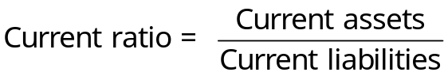
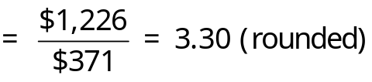

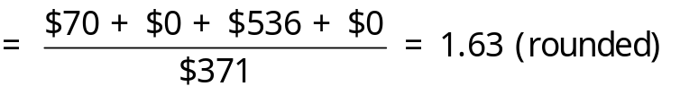
- and 4.b.
The average collection period is calculated as follows:
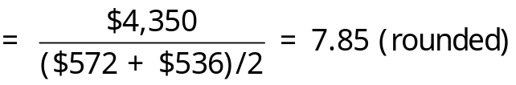
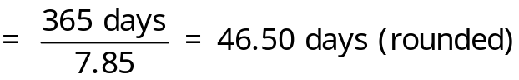

Integration Exercise 5 (continued)
The average sale period is computed as follows:
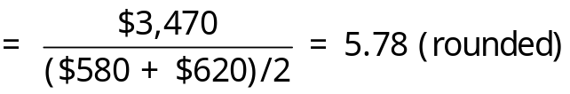
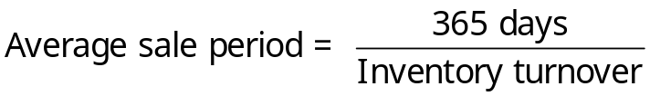
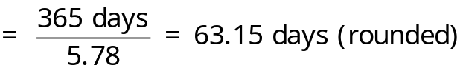
- and 5.b.
The debt-to-equity ratio is computed as follows:

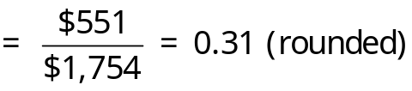
The equity multiplier is computed as follows:

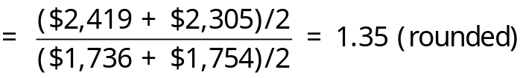

Integration Exercise 5 (continued)
- and 6.b.
The net profit margin percentage is calculated as follows:
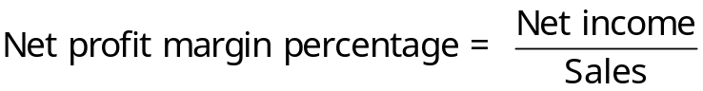
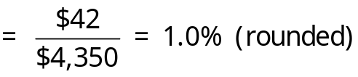
The return on equity is calculated as follows:

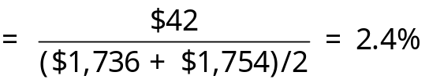
- and 7.b.
The earnings per share is calculated as follows:

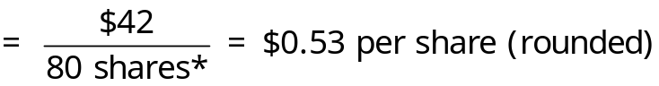
* $800,000 ÷ $10 par value per share = 80,000 shares, 80 shares (in thousands.
The dividend payout ratio is calculated as follows:

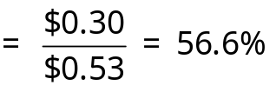
Note: The dividend per share is $24 ÷ 80 shares = $0.30.

Integration Exercise 6 (90 minutes)
1.a. The plantwide overhead rate is computed as follows:
Estimated total manufacturing overhead (a) | $1,350,000
Estimated total direct labor-hours (DLHs) (b) | 45,000 | DLHs
Plantwide overhead rate (a) ÷ (b) | $30.00 | per DLH
1.b. The overhead assigned to each product is computed as follows:
 |  | Basic |  | Advanced
 | Direct labor-hours worked (a) |  | 30,000 | 15,000
 | Manufacturing overhead rate per DLH (b) |  | $30.00 | $30.00
 | Manufacturing overhead assigned (a) × (b) |  | $900,000 | $450,000
2.a. The departmental overhead rates are computed as follows:
Molding Department:
Estimated total manufacturing overhead (a) | $787,500
Estimated total machine-hours (MHs) (b) | 22,000 | MHs
Manufacturing overhead rate (a) ÷ (b) | $35.80 | per MH
Assemble and Pack Department:
Estimated total manufacturing overhead (a) | $562,500
Estimated total direct labor-hours (DLHs) (b) | 30,000 | DLHs
Manufacturing overhead rate (a) ÷ (b) | $18.75 | per DLH
2.b. The overhead assigned to each product is computed as follows:
 |  | Basic |  | Advanced
 | Molding Department ($35.80 × 12,000 MHs; ($35.80 × 10,000 MHs) |  | $429,600 | $358,000
 | Assemble and Pack Department ($18.75 × 20,000 DLHs; $18.75 × 10,000 DLHs) |  | 375,000 | 187,500
 | Total manufacturing overhead assigned |  | $804,600 | $545,500

Integration Exercise 6 (continued)
2.c. The first step to redoing the controller’s segmented income statement is to compute each product’s cost of goods sold as follows:
 | Basic | Advanced
Direct materials ($40 × 20,000; $60 × 10,000) | $ 800,000 | $ 600,000
Direct labor ($20 × 30,000; $20 × 15,000) | 600,000 | 300,000
Manufacturing overhead (see 2.b.) | 804,600 | 545,500
Cost of goods sold | $2,204,600 | $1,445,500
The controller’s revised segmented income statement is calculated as follows:
 |  | Basic | Advanced | Total
Sales | $3,000,000 |  | $2,000,000 | $5,000,000
Cost of goods sold | 2,204,600 |  | 1,445,500 | 3,650,100
Gross margin | 795,400 |  | 554,500 | 1,349,900
Selling and administrative expenses | 720,000 |  | 480,000 | 1,200,000
Net operating income | $ 75,400 |  | $ 74,500 | $ 149,900
Note: The net operating income in this income statement ($149,900) differs from the income statement as given in the exercise ($150,000) by $100 because the departmental overhead rates have been rounded to two decimal places.

Integration Exercise 6 (continued)
3.a. The activity rates (rounded to two decimal places) are computed as follows:
Activity Cost Pool | (a)  Overhead  Cost | (b)  Activity  Level |  | (a) ÷ (b)  Activity  Rate
Machining | $417,500 | 22,000 | MH | $18.98 | per MH
Assemble and pack | $282,500 | 30,000 | DLHs | $9.42 | per DLH
Order processing | $230,000 | 250 | Orders | $920 | per order
Setups | $340,000 | 650 | Hours | $523.08 | per hour
The number of orders (250) and number of setup hours (650) are computed as follows:
 |  | Basic | Advanced |  | Total
Unit sales (a) | 20,000 |  |  | 10,000
Average order size (b) | 400 |  |  | 50
Number of orders (a) ÷ (b) | 50 |  |  | 200 | 250
Number of orders (a) | 50 |  |  | 200
Setup hours per order (b) | 1 |  |  | 3
Total setup hours (a) × (b) | 50 |  |  | 600 | 650

Integration Exercise 6 (continued)
3.b. Using the ABC system, the total manufacturing overhead assigned to the Basic and Advanced models is computed as follows (This solution uses activity rates that have been rounded to two decimal places):
 | Basic |  |  | Advanced
 | Activity  Level | Amount |  | Activity
 | Activity  Level | Amount |  | Level | Amount
Machining, at $18.98 per MH | 12,000 | $227,760 |  | 10,000 | $189,800
Assemble and pack, at $9.42 per DLH | 20,000 | 188,400 |  | 10,000 | 94,200
Order processing, at $920 per order | 50 | 46,000 |  | 200 | 184,000
Setups, at $523.08 per hour | 50 | 26,154 |  | 600 | 313,848
Total overhead cost assigned |  | $488,314 |  |  | $781,848
Note: The Other activity costs are not assigned to products because they represent unused capacity costs.
3.c. The total selling and administrative cost traced to the Basic and Advanced models is computed as follows:
 | Basic | Advanced
Sales commissions ($3,000,000 × 5%; $2,000,000 × 10%) | $150,000 | $200,000
Advertising | 150,000 | 200,000
Total traceable selling and administrative cost | $300,000 | $400,000

Integration Exercise 6 (continued)
- The contribution format income statement (adapted from Exhibit 6-8) would appear as follows:
 | Total | Basic | Advanced
Sales | $5,000,000 | $3,000,000 | $2,000,000
Variable expenses:
Direct materials | 1,400,000 | 800,000 | 600,000
Direct labor | 900,000 | 600,000 | 300,000
Sales commissions | 350,000 | 150,000 | 200,000
Total variable expenses | 2,650,000 | 1,550,000 | 1,100,000
Contribution margin | 2,350,000 | 1,450,000 | 900,000
Traceable fixed expenses:
Machining | 417,560 | 227,760 | 189,800
Assemble and pack | 282,600 | 188,400 | 94,200
Order processing | 230,000 | 46,000 | 184,000
Setups | 340,002 | 26,154 | 313,848
Advertising | 350,000 | 150,000 | 200,000
Total traceable fixed expenses | 1,620,162 | 638,314 | 981,848
Segment margin | 729,838 | $ 811,686 | $ (81,848)
Common fixed expenses:
Other (unused capacity) | 80,000
Selling and administrative | 500,000
Total common fixed expenses | 580,000
Net operating income | $ 149,838
The common fixed selling and administrative expense is computed as follows: $1,200,000 – $350,000 in sales commissions – $350,000 in advertising = $500,000.
Note: The net operating income in this income statement ($149,838) differs from the income statement as given in the exercise ($150,000) by $162 because the activity rates have been rounded to two decimal places.

Integration Exercise 6 (continued)
- The break-even point for the Advanced model is computed as follows:
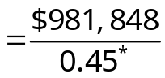
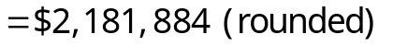
* $900,000 ÷ $2,000,000 = 0.45
- Koontz’s activity-based approach offers four improvements over its plantwide and departmental approaches. First, the ABC system allocates some of the manufacturing overhead costs (Order processing and Setups) using non-volume-related cost drivers, whereas the plantwide and departmental approaches rely exclusively on volume-related overhead cost allocation. Second, the ABC system does not assign Koontz’s unused capacity costs ($80,000) to products. Conversely, the plantwide and departmental methods rely on an absorption approach that allocates all manufacturing overhead to the units produced. Third, Koontz’s ABC approach assigns its traceable selling and administrative costs to products (i.e., sales commissions and advertising), whereas the controller’s plantwide and departmental approaches arbitrarily assign these costs to products based on sales dollars. Fourth, the ABC approach does not assign the selling and administrative costs that are organization-sustaining in nature ($500,000) to products. The controller’s plantwide and departmental approaches arbitrarily assigned these costs to products based on sales dollars.

Integration Exercise 7 (45 minutes)
1.a. The estimated total manufacturing overhead cost is computed as follows:
Y = $1,000,000 + ($12.00 per unit)(50,000 units)
 | Estimated fixed manufacturing overhead | $1,000,000
 | Estimated variable manufacturing overhead: $12.00 per unit × 50,000 units | 600,000
 | Estimated total manufacturing overhead cost | $1,600,000
The plantwide predetermined overhead rate is computed as follows:
Estimated total manufacturing overhead (a) | $1,600,000
Estimated total units produced (b) | 50,000 | units
Predetermined overhead rate (a) ÷ (b) | $32.00 | per unit
1.b. The unit product cost is computed as follows:
Direct materials | $ 78
Direct labor | 60
Manufacturing overhead | 32
Unit product cost | $170
1.c. The schedule of cost of goods manufactured is prepared as follows:
Direct materials:
Beginning raw materials inventory | $ 0
Add: Purchases of raw materials ($78 × 40,000 units) | 3,120,000
Total raw materials available | 3,120,000
Deduct: Ending raw materials inventory | 0
Raw materials used in production |  | $3,120,000
Direct labor ($60 × 40,000 units) |  | 2,400,000
Manufacturing overhead applied to work in process ($32 × 40,000 units) |  | 1,280,000
Total manufacturing costs |  | 6,800,000
Add: Beginning work in process inventory |  | 0
 |  | 6,800,000
Deduct: Ending work in process inventory |  | 0
Cost of goods manufactured |  | $6,800,000

Integration Exercise 7 (continued)
1.c. The schedule of cost of goods sold is prepared as follows:
Beginning finished goods inventory | $ 0
Add: Cost of goods manufactured | 6,800,000
Cost of goods available for sale | 6,800,000
Deduct: Ending finished goods inventory ($170 × 2,000 units | 340,000
Unadjusted cost of goods sold | 6,460,000
Add: Underapplied overhead* | 200,000
Adjusted cost of goods sold | $6,660,000
* The actual manufacturing overhead of $1,480,000 [$1,000,000 + ($12 × 40,000 units)] minus $1,280,000 of applied overhead equals underapplied overhead of $200,000.
1.d. The absorption costing net operating income is computed as follows:
Sales ($200 × 38,000 units) |  | $7,600,000
Cost of goods sold |  | 6,660,000
Gross margin | 940,000
Selling and administrative expenses ($15 × 38,000 + $350,000) | 920,000
Net operating income |  | $ 20,000
2.a. The absorption unit product cost is computed as follows:
Direct materials | $ 78
Direct labor | 60
Variable manufacturing overhead | 12
Fixed manufacturing overhead ($1,000,000 ÷ 40,000 units) | 25
Unit product cost | $175
2.b. The absorption costing net operating income is computed as follows:
Sales ($200 × 38,000 units) |  | $7,600,000
Cost of goods sold ($175 × 38,000 units) |  | 6,650,000
Gross margin | 950,000
Selling and administrative expenses ($15 × 38,000 + $350,000) | 920,000
Net operating income |  | $ 30,000

Integration Exercise 7 (continued)
- The actual costing net operating income is $10,000 higher than the normal costing net operating income because it attaches $5 additional dollars of fixed manufacturing overhead to each of the 2,000 units in ending inventory. The underlying computations are as follows:
 |  |  | Normal  Costing | Actual  Costing
Units in ending inventory (a) |  | 2,000 |  | 2,000
Fixed manufacturing overhead attached to each unit (b) |  | $20* |  | $25
Fixed manufacturing overhead deferred in ending inventory (a) × (b) |  | 40,000 |  | 50,000
* The plantwide predetermined overhead rate using normal costing is $32 per unit. This rate includes a variable component of $12 per unit and fixed component of $20 per unit (= $1,000,000 ÷ 50,000 units).
Note to professors: You can extend the analysis by explaining how allocating the underapplied overhead between finished goods and cost of goods sold would increase normal costing net operating by $10,000; thereby, equaling the actual costing net operating income.

Integration Exercise 8 (45 minutes)
Note to instructors: We recommend performing the present value calculations for this exercise using Microsoft Excel because it eliminates rounding errors that complicate the interpretation of the results. Accordingly, we present the solutions to this exercise using Microsoft Excel screen captures that rely on unrounded discount factors.
- The net present value is computed as follows:
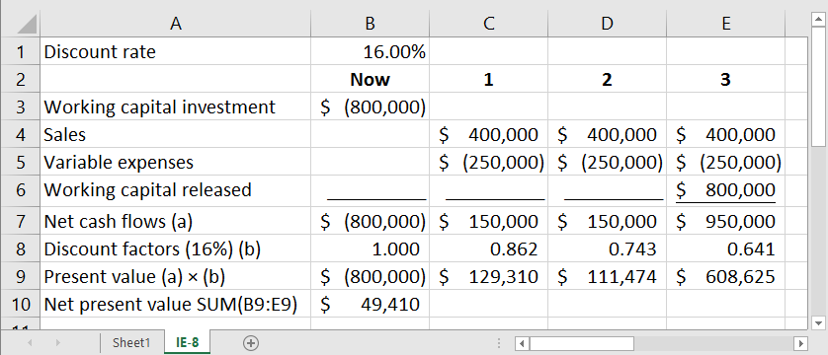

Integration Exercise 8 (continued)
- The margin, turnover, and ROI is the same for years 1 through 3:
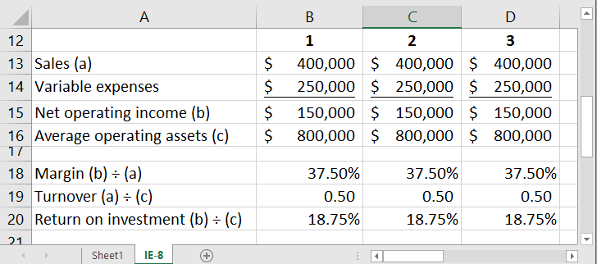
- The residual incomes for each year are computed as follows:
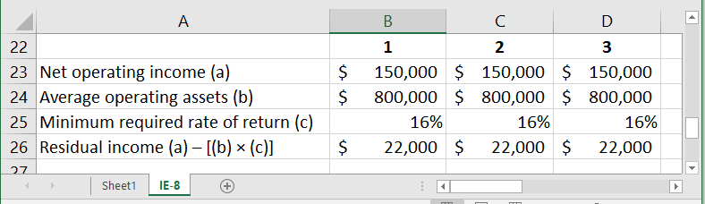
- The store manager is unlikely to pursue the investment because its ROI of 18.75% is less than her historical ROI of at least 22%. The company would want the manager to pursue the investment because it earns a return that exceeds the company’s minimum required rate of return.

Integration Exercise 8 (continued)
- The present value of the residual incomes is computed as follows:
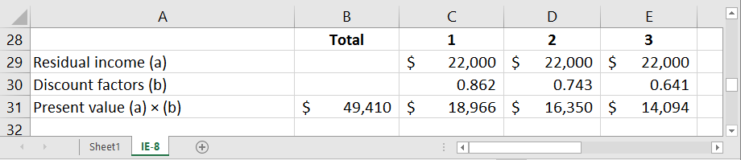
The present value of the residual incomes ($49,410) equals the net present value from requirement 1. This is not a coincidence. The key to understanding their equivalence is to focus on how the two methods use different (but equivalent) ways to account for the cost of the $800,000 investment in working capital. The net present value method accounts for the immediate $800,000 cash outflow and the $800,000 cash inflow at the end of year 3. Conversely, the residual income method assesses a 16% capital charge on the $800,000 of working capital in each of years 1 through 3. The equivalence of these two approaches can be shown as follows:
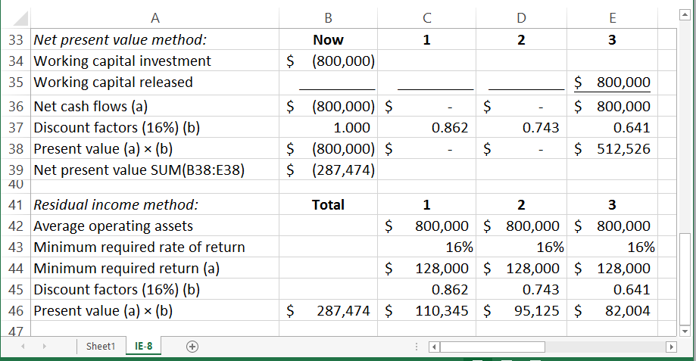
Both methods recognize a cost of $287,474 related to tying up $800,000 of working capital for three years.
Integration Exercise 9 (75 minutes)
1a.
 | Actual Quantity of Input, at Actual Price |  |  |  |  | Actual Quantity of Input, at Standard Price |  |  |  |  |  | Standard Quantity Allowed for Output, at Standard Price
 | (AQ × AP) |  |  |  |  | (AQ × SP) |  |  |  |  |  | (SQ × SP)
 | 510,000 feet × $3.20 per foot |  |  |  |  | 510,000 feet × $3.00 per foot |  |  |  |  |  | 540,000 feet* × $3.00 per foot
 | = $1,632,000 |  |  |  |  | = $1,530,000 |  |  |  |  |  | = $1,620,000
 | ↑ |  |  |  |  |  | ↑ |  |  |  |  |  | ↑
 |  | Price Variance,  $102,000 U |  |  |  |  |  | Quantity Variance,  $90,000 F
 |  | Spending Variance, $12,000 U
*30,000 units × 18 feet per unit = 540,000 feet
Alternative Solution:
Materials price variance = AQ (AP – SP)
510,000 feet ($3.20 per foot – $3.00 per foot) = $102,000 U
Materials quantity variance = SP (AQ – SQ)
$3 per foot (510,000 feet – 540,000 feet) = $90,000 F
1b.Yes, the decrease in waste is apparent because of the $90,000 favorable quantity variance.
1c.The company should revise its standard price to $3.20 per foot, thereby reflecting the current price in the just-in-time delivery environment. The old standard price of $3.00 per foot is no longer relevant.

Integration Exercise 9 (continued)
2a.
 | Actual Hours of Input, at the Actual Rate |  |  |  |  | Actual Hours of Input, at the Standard Rate |  |  |  |  |  | Standard Hours Allowed for Output, at the Standard Rate
 | (AH × AR) |  |  |  |  | (AH × SR) |  |  |  |  |  | (SH × SR)
 | 90,000 hours × $15.85 per hour |  |  |  |  | 90,000 hours × $16.00 per hour |  |  |  |  |  | 75,000 hours* × $16.00 per hour
 | = $1,426,500 |  |  |  |  | = $1,440,000 |  |  |  |  |  | = $1,200,000
 | ↑ |  |  |  |  |  | ↑ |  |  |  |  |  | ↑
 |  | Rate Variance,  $13,500 F |  |  |  |  |  | Efficiency Variance,  $240,000 U
 |  | Spending Variance, $226,500 U

*30,000 units × 2.5 hours per unit = 75,000 hours
Alternative Solution:
Labor rate variance = AH (AR – SR)
90,000 hours ($15.85 per hour – $16.00 per hour) = $13,500 F
Labor efficiency variance = SR (AH – SH)
$16.00 per hour (90,000 hours – 75,000 hours) = $240,000 U

Integration Exercise 9 (continued)
2b. No, the labor efficiency variance is not appropriate as a measure of performance in this situation. The reasons are:
- Labor is largely a fixed cost rather than a variable cost since the company maintains a stable workforce to operate its production line. Thus, the variance is not an effective measure of efficiency.
- In a lean environment the goal is to produce only as needed to meet demand. This often conflicts with the goal of having high labor efficiency, which requires that labor be fully utilized producing output. If that output is not demanded by customers, the result of fully utilizing labor is a buildup of excess work in process and finished goods inventories. This is anathema in a lean environment. Unfortunately, the situation posed in the problem is a common one as companies switch from a traditional system to lean production, and sometimes the lean approach is wrongly criticized because of misplaced emphasis on efficiency variances. In a lean environment, it is an interesting paradox that one of the “costs” of greater efficiency on the production line is greater “inefficiency” on the part of labor as it is occasionally idle or as it spends time at various tasks other than producing goods.

Integration Exercise 9 (continued)
3a.
 | Actual Hours of Input, at the Actual Rate |  |  |  |  | Actual Hours of Input, at the Standard Rate |  |  |  |  |  | Standard Hours Allowed for Output, at the Standard Rate
 | (AH × AR) |  |  |  |  | (AH × SR) |  |  |  |  |  | (SH × SR)
 | 90,000 hours × $2.30 per hour |  |  |  |  | 90,000 hours × $2.80 per hour |  |  |  |  |  | 75,000 hours* × $2.80 per hour
 | = $207,000 |  |  |  |  | = $252,000 |  |  |  |  |  | = $210,000
 | ↑ |  |  |  |  |  | ↑ |  |  |  |  |  | ↑
 |  | Rate Variance,  $45,000 F |  |  |  |  |  | Efficiency Variance,  $42,000 U
 |  | Spending Variance, $3,000 F
*30,000 units × 2.5 hours per unit = 75,000 hours
Alternative Solution:
Variable overhead spending variance = (AH × AR) – (AH × SR)
$207,000 – (90,000 hours × $2.80 per hour) = $45,000 F
Variable overhead efficiency variance = SR (AH – SH)
$2.80 per hour (90,000 hours – 75,000 hours) = $42,000 U
3b. Direct labor-hours is not an appropriate cost driver for variable manufacturing overhead in the company’s lean environment. It is doubtful that a correlation still exists between direct labor and variable manufacturing overhead cost. Direct labor time is now largely a fixed cost. Variable manufacturing overhead, however, will tend to rise and fall with actual changes in production. If variable manufacturing overhead cost was correlated with direct labor, the actual variable manufacturing overhead cost for June should have been $252,000 (90,000 hours × $2.80 per hour). But actual variable manufacturing overhead cost was only $207,000—which is very near the $210,000 standard cost allowed for the month’s output. Thus, it appears that as production has been cut back, variable manufacturing overhead cost has also decreased, even though direct labor time has remained quite stable.
Integration Exercise 9 (continued)
- a. and b.
 | Month
 | April |  | May |  | June
Throughput time—hours:
Processing time (x) | 2.6 | 2.5 |  | 2.4
Inspection time | 1.3 | 0.9 |  | 0.1
Move time | 1.9 | 1.4 |  | 0.6
Queue time | 8.2 | 5.2 |  | 1.9
Total throughput time (y) | 14.0 | 10.0 |  | 5.0
Manufacturing cycle efficiency (MCE):
Processing time (x) ÷ Throughput time (y) | 18.6% |  | 25.0% |  | 48.0%
Note that the manufacturing cycle efficiency has improved dramatically over the last three months. This means that non-value-added time is being eliminated.
- With lean production, the goal is to match production with demand rather than to just fill labor time. Thus, the traditional labor variances are often unfavorable. Throughput time and MCE focus on all elements of manufacturing—not just labor time. These other elements, which are independent of labor time, are showing greater efficiency each month as the company eliminates non-value-added activities.
Throughput time and MCE are more appropriate in this situation since they focus on those elements that are of greatest importance in a lean environment. The labor efficiency variance has little or no significance in such an environment.

Integration Exercise 10 (60 minutes)
 | Total Cost  (a) | Total Activity  (b) |  | Activity Rate  (a) ÷ (b)
Sales support | $3,600,000 | 24,000 | calls | $150 | per call
Order processing | 1,720,000 | 8,600 | orders | $200 | per order
Warehousing | 940,000 | 117,500 | square feet | $8 | per square foot
Packing and shipping | 520,000 | 104,000 | pounds shipped | $5 | per pound shipped
Assignment of expenses to markets:
 | Commercial Market |  |  |  | Home Market |  |  | School Market
 | Amount of Activity |  | Amount |  | Amount of Activity | Amount |  | Amount of Activity | Amount
Sales support, at $150 per call |  | 8,000 | $1,200,000 |  | 5,000 | $ 750,000 |  | 11,000 | $1,650,000
Order processing, at $200 per order |  | 1,750 | 350,000 |  | 5,200 | 1,040,000 |  | 1,650 | 330,000
Warehousing, at $8 per square foot |  | 35,000 | 280,000 |  | 65,000 | 520,000 |  | 17,500 | 140,000
Packing and shipping, at $5 per pound |  | 24,000 | 120,000 |  | 16,000 | 80,000 |  | 64,000 | 320,000

Integration Exercise 10 (continued)
- The segmented income statement follows (All dollar amounts are in thousands of dollars):

 |  |  |  | Market
 | Total |  |  | Commercial |  |  | Home |  |  | School
 | Amount | % |  | Amount | % |  | Amount | % |  | Amount | %
Sales | $20,000 | 100.0 |  | $8,000 | 100.0 |  | $5,000 | 100.0 |  | $7,000 | 100.0
Less variable expenses:
Cost of goods sold | 9,500 | 47.5 |  | 3,900 | 48.8 |  | 2,400 | 48.0 |  | 3,200 | 45.7
Sales support | 3,600 | 18.0 |  | 1,200 | 15.0 |  | 750 | 15.0 |  | 1,650 | 23.6
Order processing | 1,720 | 8.6 |  | 350 | 4.4 |  | 1,040 | 20.8 |  | 330 | 4.7
Packing and shipping | 520 | 2.6 |  | 120 | 1.5 |  | 80 | 1.6 |  | 320 | 4.6
Total variable expenses | 15,340 | 76.7 |  | 5,570 | 69.6 |  | 4,270 | 85.4 |  | 5,500 | 78.6
Contribution margin | 4,660 | 23.3 |  | 2,430 | 30.4 |  | 730 | 14.6 |  | 1,500 | 21.4
Less traceable fixed expenses:
Warehousing | 940 | 4.7 |  | 280 | 3.5 |  | 520 | 10.4 |  | 140 | 2.0
Advertising | 1,460 | 7.3 |  | 700 | 8.8 |  | 180 | 3.6 |  | 580 | 8.3
General mgmt—salaries | 410 | 2.1 |  | 150 | 1.9 |  | 120 | 2.4 |  | 140 | 2.0
Total traceable fixed expenses | 2,810 | 14.1 |  | 1,130 | 14.1 |  | 820 | 16.4 |  | 860 | 12.3
Market segment margin | 1,850 | 9.3 |  | $1,300 | 16.3 |  | $(90) | (1.8) |  | $ 640 | 9.1
[The statement is continued on the next page]

Integration Exercise 10 (continued)
 |  |  |  | Market
 | Total |  |  | Commercial |  |  | Home |  |  | School
 | Amount | % |  | Amount | % |  | Amount | % |  | Amount | %
Market segment margin | 1,850 | 9.3 |  | $1,300 | 16.3 |  | $(90) | (1.8) |  | $ 640 | 9.1
Less common fixed expenses not traceable to markets:
Advertising | 230 | 1.2
General management | 900 | 4.5
Total common fixed expenses | 1,130 | 5.7
Net operating income | $ 720 | 3.6
Note: Percentage figures may not total down due to rounding.

Integration Exercise 10 (continued)
- The following insights are revealed by the new segmented income statement:
Commercial market:
    - The commercial market is the company’s strongest segment rather than its weakest. It is generating enough segment margin by itself to cover all of the company’s common costs.
    - The manager of the commercial market is doing an outstanding job of controlling expenses. Expenses as a percentage of sales are lower than the company average for every category except cost of sales and advertising, and these latter two costs do not seem out of line.
Home Market:
    - The home market spends very little on advertising. A more generous advertising budget may yield a substantial increase in sales in this segment.
    - Order processing expenses are extremely high in the home market. Note from the data in the problem that more orders are written in this market (5,200 orders) than in the other two markets combined. This large number of orders, combined with the low overall sales in the home market, means that the home market is taking many small orders.
    - Warehousing expenses are also high in the home market.
    - The home market is not covering its own traceable costs. If sales can’t be increased through a more generous advertising budget and through a concerted effort to make larger sales per order and other actions, then consideration should be given to eliminating this market segment.
School Market:
    - The school market has extremely high sales support expenses. This is because nearly as many sales calls are made to this market (11,000 calls) as are made to the other two markets combined. Can contacts be made by phone or by other means?
    - Over 60% of the packing and shipping expenses are traceable to the school market. The company may want to investigate cheaper shipping methods.

Integration Exercise 11 (75 minutes)
This is a difficult case that will challenge the best students. Part of the challenge is simply to understand the alternatives. As an aid, a diagram of the two alternatives, which we will call Alternatives 1 and 2, is shown below, together with the relevant data.
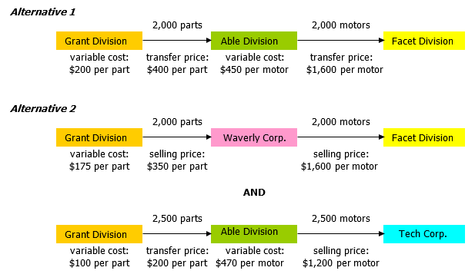

Integration Exercise 11 (continued)
In both parts of the case the general fixed overhead costs are irrelevant since they are allocated costs that will remain the same regardless of which alternative is accepted. Also note that the same amount of total machine time would be consumed in both the Grant Division’s plant and the Able Division’s plant regardless of which order is accepted. Thus, the amount of machine time that would be required is not a factor in the decision.
Grant’s plant:
Facet Division order:
2,000 motors × 2.5 hours per motor = 5,000 hours.
Tech Corporation order:
2,500 motors × 2.0 hours per motor = 5,000 hours.
Able’s plant:
Facet Division order:
2,000 motors × 5.0 hours per motor = 10,000 hours.
Tech Corporation order:
2,500 motors × 4.0 hours per motor = 10,000 hours.
- The Able Division would accept the order from the Facet Division. Computations to support this conclusion follow:
Expected contribution margin from the Facet Division order:
Sales revenue to Able Division (2,000 motors × $1,600 per motor) |  | $3,200,000
Less variable costs:
Transfer price to Grant Division(2,000 parts × $400 per part) | $800,000
Other variable costs (2,000 motors × $450 per motor) | 900,000 | 1,700,000
Contribution margin |  | $1,500,000

Integration Exercise 11 (continued)
Expected contribution margin from Tech Corporation order:
Sales revenue to Able Division (2,500 motors × $1,200 per motor) |  | $3,000,000
Less variable costs:
Transfer price to Grant Division (2,500 parts × $200 per part) | $ 500,000
Other variable costs (2,500 motors × $470 per motor) | 1,175,000 | 1,675,000
Contribution margin |  | $1,325,000
Thus, the Able Division will net $175,000 ($1,500,000 – $1,325,000) more in contribution margin by taking the order from the Facet Division.
- From the perspective of the company as a whole, the situation is both simpler and more complex. It is simpler because transfer prices are irrelevant. Whatever one division pays, the other receives. From the standpoint of the entire company, money is taken out of one pocket and put into the other. The situation is more complex in that the company must take into account that if Able Division accepts the order from Tech Corporation, Facet Division will need to acquire its motors from Waverly Corporation rather than from Able Division. This is Alternative 2 in the diagram on the first page of the solution. But let’s start with Alternative 1, the simpler alternative. From the standpoint of the entire company, the cost of the motors transferred to Facet Division is $650 per motor, the variable costs of Grant Division plus the variable costs of Able Division. The total cost of the motors would be $1,300,000 (2,000 motors @ $650 per motor). This is restated in slightly different form below:
Alternative 1
Facet Division acquires motors from Able Division, which acquires parts from Grant Division.
Grant Division’s variable expenses (2,000 parts × $200 per part) | $ 400,000
Able Division’s variable expenses (2,000 motors × $450 per motor) | 900,000
Total cost of Alternative 1 | $1,300,000

Integration Exercise 11 (continued)
Alternative 2
This alternative is more complex than Alternative 1. There are really two parts to this alternative. In the first part, Facet Division purchases the required motors from Waverly Corporation, which purchases parts from Grant Division. In the second part, Able Division sells motors to Tech Corporation using parts supplied by Grant Division. (Refer back to the diagram.) We will compute the financial consequences of these two parts separately and then combine them.
Part 1: Facet Division’s purchase of motors
Facet Division’s payment to Waverly Corporation (2,000 motors × $1,600 per motor) | $3,200,000
Waverly Corporation’s payments to Grant Division (2,000 parts × $350 per part) | (700,000)
Grant Division’s variable expenses (2,000 parts × $175 per part) | 350,000
Total cost (a) | $2,850,000
Part 2: Tech Corporation’s purchase of motors
Tech Corporation’s payments to Able Division (2,500 motors × $1,200 per motor) | $3,000,000
Able Division’s variable expenses (2,500 motors × $470 per motor) | (1,175,000)
Grant Division’s variable expenses (2,500 motors × $100 per motor) | (250,000)
Total contribution margin (b) | $1,575,000
Net cost to the company of Alternative B (a) – (b) | $1,275,000
Since the $1,275,000 cost of Alternative B is less than the $1,300,000 cost of Alternative A, it is the preferred alternative.

Integration Exercise 12 (45 minutes)

 | General Admin. | Cost Accounting |  | Laundry | Convention Center | Food Services | Guest Lodging
Variable costs | $ 0 | $70,000 | $143,000 |  | $ 0 | $52,000 |  | $ 24,000
Cost Accounting allocation:
$70,000 × (800 ÷ 14,000) |  | (4,000) | 4,000
$70,000 × (1,200 ÷ 14,000) |  | (6,000) |  |  | 6,000
$70,000 × (3,000 ÷ 14,000) |  | (15,000) |  |  |  | 15,000
$70,000 × (9,000 ÷ 14,000) |  | (45,000) |  |  |  |  |  | 45,000
Laundry allocation:
$147,000 × (20,000 ÷ 245,000) |  |  | (12,000) |  | 12,000
$147,000 × (15,000 ÷ 245,000) |  |  | (9,000) |  |  | 9,000
$147,000 × (210,000 ÷ 245,000) |  |  | (126,000) |  |  |  |  | 126,000
Total variable costs | $ 0 | $ 0 | $ 0 |  | $18,000 | $76,000 |  | $195,000

Integration Exercise 12 (continued)

 | General Admin. | Cost Accounting | Laundry | Convention Center | Food Services | Guest Lodging
Fixed costs | $200,000 | $110,000 | $65,900 | $ 95,000 | $375,000 | $486,000
General Administration allocation:
$200,000 × 10% | (20,000) | 20,000
$200,000 × 4% | (8,000) |  | 8,000
$200,000 × 30% | (60,000) |  |  | 60,000
$200,000 × 16% | (32,000) |  |  |  | 32,000
$200,000 × 40% | (80,000) |  |  |  |  | 80,000
Cost Accounting allocation:
$130,000 × 7% |  | (9,100) | 9,100
$130,000 × 13% |  | (16,900) |  | 16,900
$130,000 × 20% |  | (26,000) |  |  | 26,000
$130,000 × 60% |  | (78,000) |  |  |  | 78,000
Laundry allocation:
$83,000 × 10% |  |  | (8,300) | 8,300
$83,000 × 6% |  |  | (4,980) |  | 4,980
$83,000 × 84% |  |  | (69,720) |  |  | 69,720
Total fixed costs | $ 0 | $ 0 | $ 0 | $180,200 | $437,980 | $713,720

Integration Exercise 12 (continued)
- The total direct costs and allocated service department costs assigned to each operating department is:
 | Convention Center | Food Services | Guest Lodging | Total
Variable costs | $ 18,000 | $76,000 | $195,000 | $ 289,000
Fixed costs | 180,200 | 437,980 | 713,720 | 1,331,900
Total costs | $198,200 | $513,980 | $908,720 | $1,620,900

Integration Exercise 13 (90 minutes)
- The plantwide overhead rate would include overhead costs from all five manufacturing departments. It would be computed as follows:
Estimated manufacturing overhead costs:
Molding | $1,960,500
Component | 1,620,000
Assembly | 2,399,500
Power | 1,840,000
Maintenance | 400,000
Total hours | $8,220,000

Estimated direct labor-hours:
Molding | 50,000
Component | 200,000
Assembly | 150,000
Total hours | 400,000
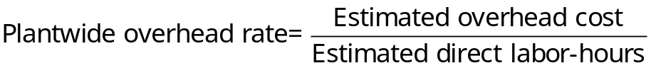
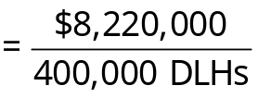
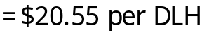

Integration Exercise 13 (continued)
2a.
 | Power | Maintenance | Molding | Component | Assembly
Variable cost | $ 640,000 | $ 25,000
Power allocations:
$640,000 × (36,000 ÷ 80,000) | (288,000) |  | $ 288,000
$640,000 × (32,000 ÷ 80,000) | (256,000) |  |  | $256,000
$640,000 × (12,000 ÷ 80,000) | (96,000) |  |  |  | $ 96,000
Maintenance allocations:
$25,000 × (9,000 ÷ 12,500) |  | (18,000) | 18,000
$25,000 × (2,500 ÷ 12,500) |  | (5,000) |  | 5,000
$25,000 × (1,000 ÷ 12,500) |  | (2,000) |  |  | 2,000
Total variable costs | $ 0 | $ 0 | 306,000 | 261,000 | 98,000
Fixed costs | $1,200,000 | $375,000
Power allocations:
$1,200,000 × 50% | (600,000) |  | 600,000
$1,200,000 × 35% | (420,000) |  |  | 420,000
$1,200,000 × 15% | (180,000) |  |  |  | 180,000
Maintenance allocations:
$375,000 × 70% |  | (262,500) | 262,500
$375,000 × 20% |  | (75,000) |  | 75,000
$375,000 × 10% |  | (37,500) |  |  | 37,500
Total fixed costs | $ 0 | $ 0 | 862,500 | 495,000 | 217,500
Total allocated costs |  |  | $1,168,500 | $756,000 | $315,500

Integration Exercise 13 (continued)
2. | b. |  | Molding | Component | Assembly
 |  | Traceable overhead costs | $1,960,500 | $1,620,000 | $2,399,500
 |  | Allocated service department costs (requirement 2a) | $1,168,500 | $ 756,000 | $ 315,500
 |  | Total overhead costs | $3,129,000 | $2,376,000 | $2,715,000
 |  | Divide by machine-hours | ÷ 87,500
 |  | Divide by direct labor-hours |  | ÷ 200,000 | ÷ 150,000
 |  | Predetermined overhead rat | $ 35.76 | $ 11.88 | $ 18.10
3.a. The overhead allocated to the attaché case under the plantwide approach is:
Direct labor hours (a) | 7,500
Plantwide overhead rate (b) | $20.55
Applied overhead (a) × (b) | $154,125
3. b. The overhead allocated to the attaché case under the departmental approach is:
Molding department:
$35.76 per machine-hour × 3,000 machine-hours | $107,280
Component department:
$11.88 per direct labor-hour × 2,500 direct labor-hours | 29,700
Assembly department:
$18.10 per direct labor-hour × 4,000 direct labor-hours | 72,400
Total cost allocated | $209,380
- The plantwide approach is undercosting the attaché case. If the company uses cost-plus pricing for products such as the attaché case it will set selling prices that are too low for these types of products relative to competitors who better understand their product costs. In all likelihood, the plantwide approach is also overcosting numerous products resulting in prices that are too high relative to competitors. The fact that the company is overcosting some products and undercosting others—which in turn leads to unwise pricing decisions—helps explain why the company is experiencing declining profits.

Integration Exercise 14 (60 minutes)
- Step-down method
 |  |  | Factory Admini-stration | Custodial Services | Personnel | Mainte-nance | Machining | Assembly
 | Departmental costs before allocations |  | $270,000 | $ 68,760 | $ 28,840 | $ 45,200 | $376,300 | $175,900
 | Allocations:
 | Factory Administration costs ($270,000 ÷ 150,000 labor-hours = $1.80 per labor-hour) |  | (270,000) | 5,400 | 9,000 | 39,600 | 54,000 | 162,000
 | Custodial Services costs ($74,160 ÷ 103,000 square feet = $0.72 per square foot) |  |  | (74,160) | 2,160 | 7,200 | 50,400 | 14,400
 | Personnel costs ($40,000 ÷ 125 employees = $320 per employee) |  |  |  | (40,000) | 8,000 | 12,800 | 19,200
 | Maintenance costs ($100,000 ÷ 80,000 MH = $1.25 per MH) |  |  |  |  | (100,000) | 87,500 | 12,500
 | Total costs after allocations |  | $ 0 | $ 0 | $ 0 | $ 0 | $581,000 | $384,000
 | Divide by machine-hours |  |  |  |  |  | ÷ 70,000
 | Divide by direct labor-hours |  |  |  |  |  |  | ÷ 80,000
 | Overhead rate |  |  |  |  |  | $8.30 | $4.80

Integration Exercise 14 (continued)
- Direct method
 |  | Factory Admini-stration | Custodial Services |  | Personnel | Mainte-nance | Machining | Assembly
 | Departmental costs before allocations | $270,000 |  | $68,760 | $28,840 | $45,200 | $376,300 | $175,900
 | Allocations:
 | Factory Administration costs(30/120, 90/120) | (270,000) |  |  |  |  | 67,500 | 202,500
 | Custodial Services costs(70/90, 20/90) |  |  | (68,760) |  |  | 53,480 | 15,280
 | Personnel costs(40/100, 60/100) |  |  |  | (28,840) |  | 11,536 | 17,304
 | Maintenance costs(70/80, 10/80) |  |  |  |  | (45,200) | 39,550 | 5,650
 | Total costs after allocations | $ 0 |  | $ 0 | $ 0 | $ 0 | $548,366 | $416,634
 | Divide by machine-hours |  |  |  |  |  | ÷ 70,000
 | Divide by direct labor-hours |  |  |  |  |  |  | ÷ 80,000
 | Overhead rate (rounded) |  |  |  |  |  | $7.834 | $5.208

Integration Exercise 14 (continued)
- Plantwide rate
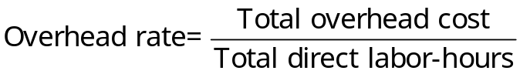
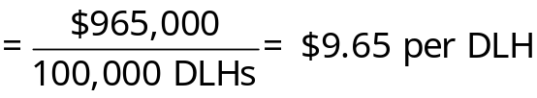
- The amount of overhead cost assigned to the job would be:
Step-down method:
Machining Department: $8.30 per machine-hour × 190 machine-hours | $1,577
Assembly Department: $4.80 per direct labor-hour × 75 direct labor-hours | 360
Total overhead cost | $1,937
Direct method:
Machining Department: $7.834 per machine-hour × 190 machine-hours | $1,488
Assembly department: $5.208 per direct labor-hour × 75 direct labor-hours | 391
Total overhead cost | $1,879
Plantwide method:
$9.65 per direct labor-hour × 100 direct labor-hours | $965
The plantwide method, which is based on direct labor-hours, assigns very little overhead cost to the job because it requires little labor time. Assuming that Factory Administrative costs really do vary in proportion to labor-hours, Custodial Services with square feet occupied, and so on, the company will tend to undercost such jobs if a plantwide overhead rate is used (and it will tend to overcost jobs requiring large amounts of labor time). The direct method is better than the plantwide method, but the step-down method will generally provide the most accurate overhead rates of the three methods.

Integration Exercise 15 (45 minutes)
 | Total Company | Cook-book |  | Travel Guide | Handy Speller
Sales | $300,000 |  | $90,000 | $150,000 | $60,000
Variable expenses:
Printing cost | 102,000 |  | 27,000 | 63,000 | 12,000
Sales commissions | 30,000 |  | 9,000 | 15,000 | 6,000
Total variable expenses | 132,000 |  | 36,000 | 78,000 | 18,000
Contribution margin | 168,000 |  | 54,000 | 72,000 | 42,000
Traceable fixed expenses:
Advertising | 36,000 |  | 13,500 | 19,500 | 3,000
Salaries | 33,000 |  | 18,000 | 9,000 | 6,000
Equipment depreciation* | 9,000 |  | 2,700 | 4,500 | 1,800
Warehouse rent** | 12,000 |  | 1,800 | 6,000 | 4,200
Total traceable fixed expenses | 90,000 |  | 36,000 | 39,000 | 15,000
Product line segment margin | 78,000 |  | $18,000 | $ 33,000 | $27,000
Common fixed expenses:
General sales | 18,000
General administration | 42,000
Depreciation—office facilities | 3,000
Total common fixed expenses | 63,000
Net operating income | $ 15,000
* $9,000 × 30%, 50%, and 20%, respectively.
** 48,000 square feet × $3 per square foot = $144,000; $144,000 ÷ 12 months = $12,000 per month. $12,000 ÷ 48,000 square feet = $0.25 per square foot per month.
$0.25 per square foot × 7,200 square feet = $1,800; $0.25 per square foot × 24,000 square feet = $6,000; and $0.25 per square foot × 16,800 square feet = $4,200.

Integration Exercise 15 (continued)

  - No, the cookbook line should not be eliminated. The cookbook is covering all of its own costs and is generating an $18,000 segment margin toward covering the company’s common costs and toward profits.

 | Cook-book | Travel Guide | Handy Speller
Contribution margin (a) | $54,000 | $72,000 | $42,000
Sales (b) | $90,000 | $150,000 | $60,000
Contribution margin ratio (a) ÷ (b) | 60% | 48% | 70%
It is probably unwise to focus all available resources on promoting the travel guide. The company is already spending more on the promotion of this product than on the other two products combined. Furthermore, the travel guide has the lowest contribution margin ratio of the three products. Therefore, a dollar of sales of the travel guide generates less profit than a dollar of sales of either of the two other products. Nevertheless, we cannot say for sure which product should be emphasized in this situation without more information. The problem states that there is ample demand for all three products, which suggests that there is no idle capacity. If the equipment is being fully utilized, increasing the production of any one product would require cutting back production of the other products.

Integration Exercise 16 (8 hours+)
Note to Instructors: We recommend providing students with the row headings for the ending finished goods inventory budget (in Requirement 6) as depicted in the solution to simplify the complexity of the assignment.
- The sales budget and schedule of expected cash collections:
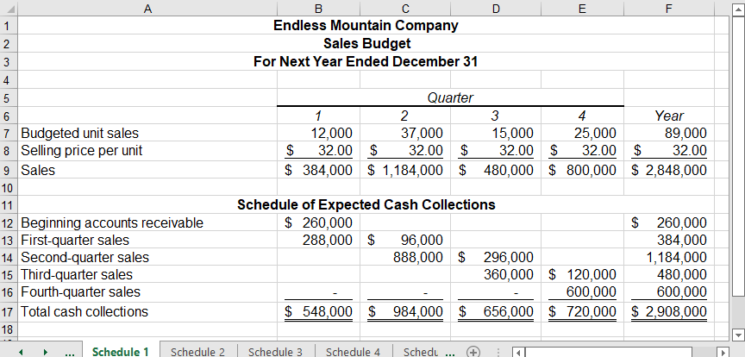
- The production budget:
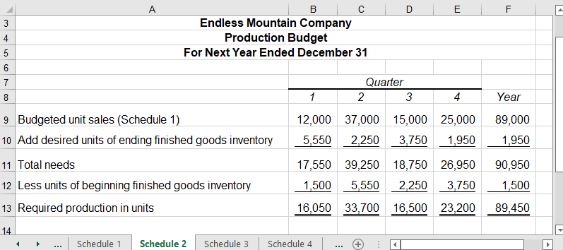

Integration Exercise 16 (continued)
- The direct materials budget and schedule of expected cash disbursements for purchases of materials:
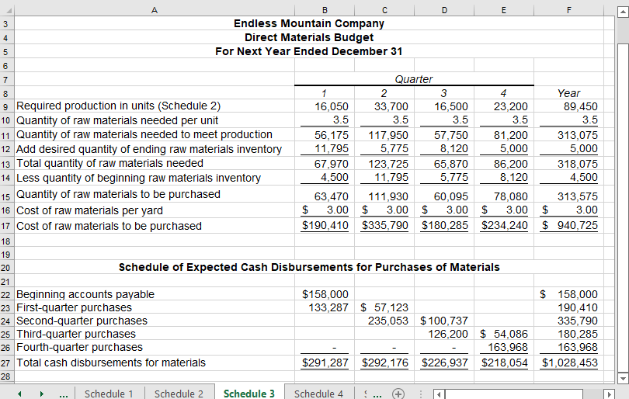
- The direct labor budget:
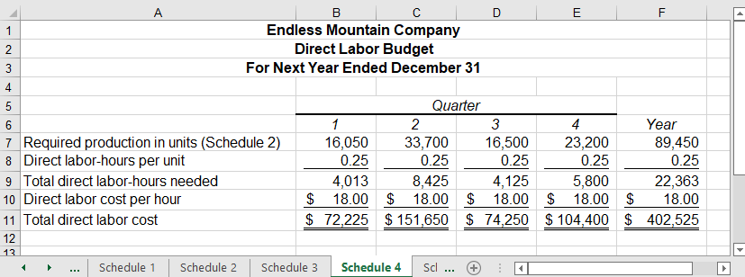

Integration Exercise 16 (continued)
- The manufacturing overhead budget:
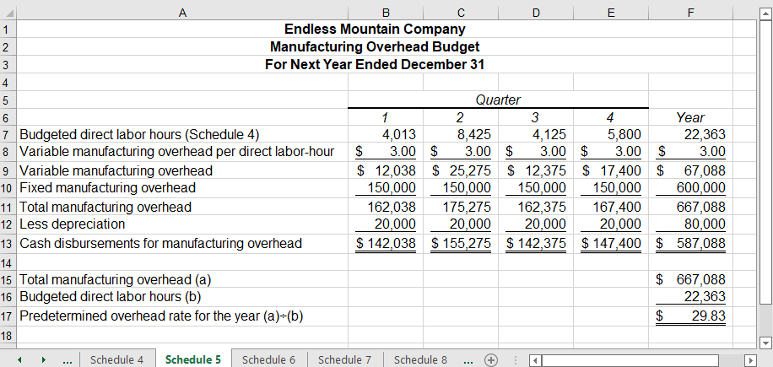
- The ending finished goods inventory budget:
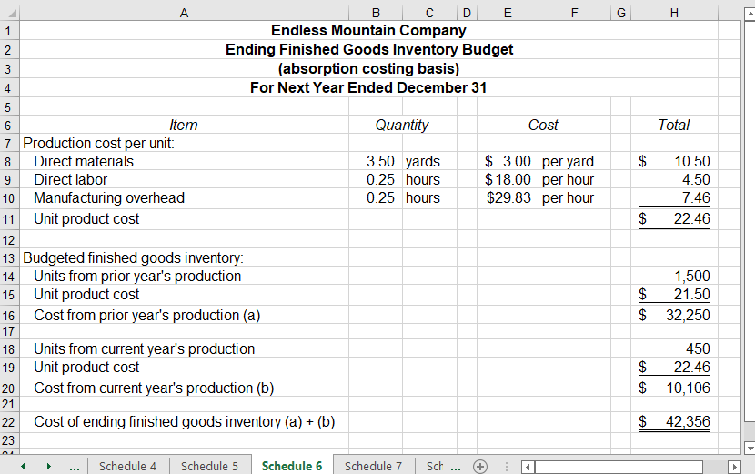

Integration Exercise 16 (continued)
- The selling and administrative expense budget:
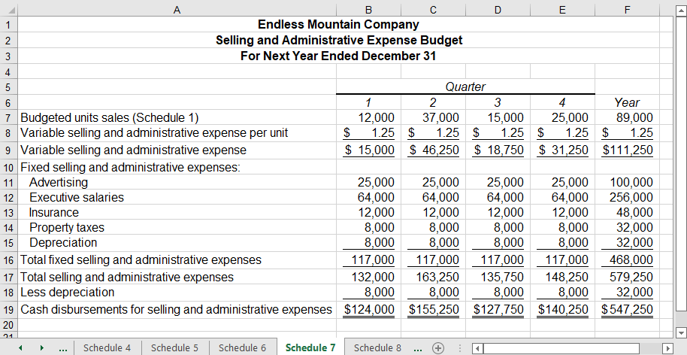
- The cash budget:
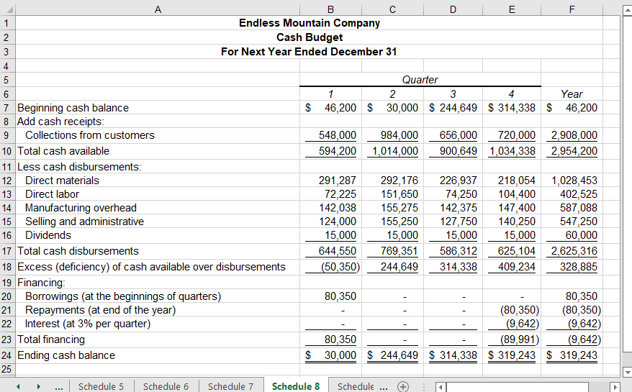

Integration Exercise 16 (continued)
- The income statement:
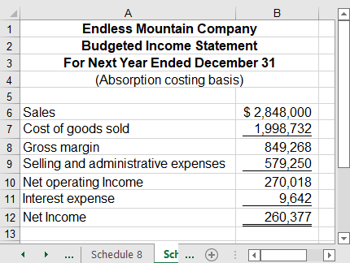

Integration Exercise 16 (continued)
- The balance sheet:
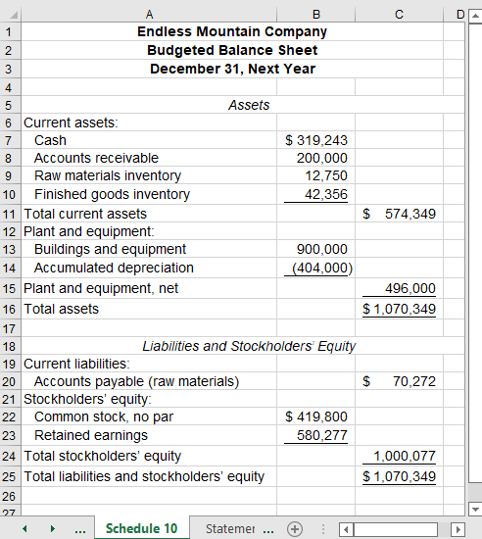

Integration Exercise 17 (45 minutes)
- The net cash provided by operating activities:
Step 1: The company did not sell or retire any plant and equipment during the year; therefore, the $112,000 ($404,000 – $292,000) increase in Accumulated Depreciation equals the credit to the account that is added to net income.
Step 2: The guidelines from Exhibit 15-2 can be used to analyze the changes in noncash balance sheet accounts that impact net income as follows:
 | Increase in Account Balance | Decrease in Account Balance
Current Assets
Accounts receivable |  | +60,000
Raw materials inventory | – 1,500
Finished goods inventory | – 10,106
Current Liabilities
Accounts payable |  | – 87,728
Step 3: There are no gains or losses on the sale of assets.

Integration Exercise 17 (continued)
The net cash provided by operating activities is computed as follows:
 | Net income |  | $260,377
 | Adjustments to convert net income to a cash basis:
 | Depreciation | $112,000
 | Decrease in accounts receivable | 60,000
 | Increase in raw materials inventory | (1,500)
 | Increase in finished goods inventory | (10,106)
 | Decrease in accounts payable | (87,728) | 72,666
 | Net cash provided by operating activities |  | $333,043

Integration Exercise 17 (continued)
- The budgeted statement of cash flows:
Endless Mountain Company’s budget does not include any investing activities. The financing activities (as shown in the cash budget) include borrowing and repaying $80,350 and paying $60,000 in dividends for the year. Thus, the complete statement of cash flows (as shown in Excel) would appear as follows:
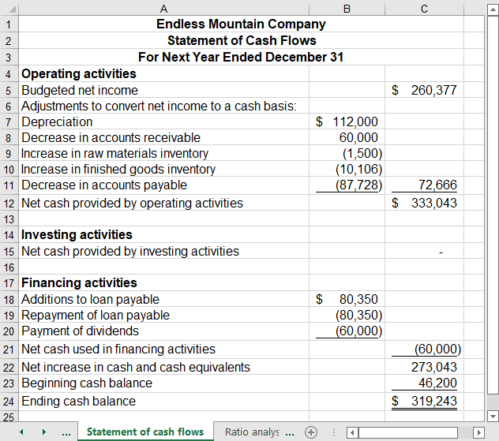

Integration Exercise 18 (60 minutes)
1.a. Working capital:
1.b. The current ratio:

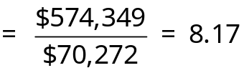
2.a. The accounts receivable turnover:

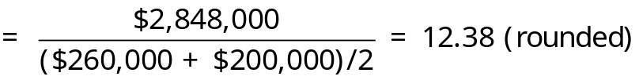
2.b. The average collection period:
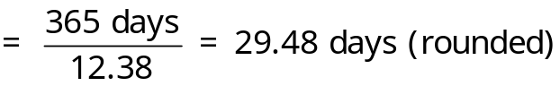
2.c. The inventory turnover:
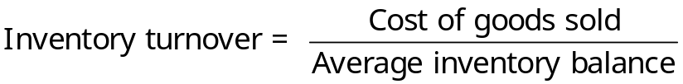
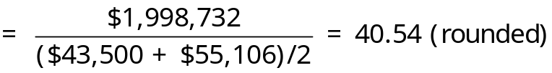

Integration Exercise 18 (continued)
2.d. The average sale period:
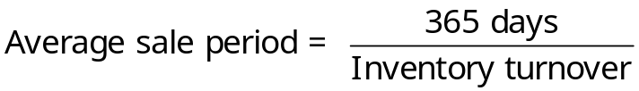
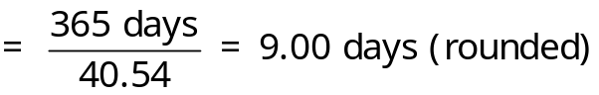
2.e. The operating cycle:
3.a. The times interest earned ratio:

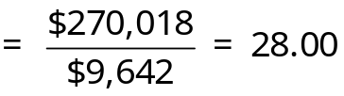
3.b. The equity multiplier:

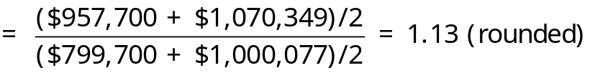
4.a. The net profit margin percentage:
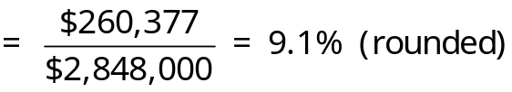

Integration Exercise 18 (continued)
4.b. The return on equity:

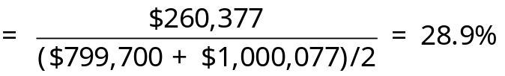

Integration Exercise 18 (continued)
- Management preferences and the accompanying explanations are summarized below:
 |  | Increase | Decrease | Explanation
1.a. | Working capital | √ |  | Generally speaking, increasing work in capital improves liquidity. However, if working capital grows due to bloated inventories, aging accounts receivables, or dormant cash hoards, it may signal poor management performance.
1.b. | Current ratio | √ |  | Generally speaking, increasing the current ratio improves liquidity. However, if the current ratio grows due to bloated inventories, aging accounts receivables, or dormant cash hoards, it may signal poor management performance.
2.a. | Accounts receivable turnover | √ |  | An increasing accounts receivable turnover indicates that management is collecting cash from customers sooner.
2.b. | Average collection period |  | √ | A decreasing average collection period indicates that management is collecting cash from customers in fewer days.
2.c. | Inventory turnover | √ |  | An increasing inventory turnover indicates that management is achieving a better balance between inventory levels and sales.

Integration Exercise 18 (continued)
 |  | Increase | Decrease | Explanation
2.d. | Average sale period |  | √ | A decreasing average sale period indicates that inventory is on hand fewer days before being sold to customers.
2.e. | Operating cycle |  | √ | A decreasing operating cycle means that the elapsed time from when inventory is purchased from suppliers until cash is collected from customers is shrinking.
3.a. | Times interest earned ratio | √ |  | An increasing times interest earned ratio signifies that a company can pay it lenders’ interest obligations with growing ease.
3.b. | Equity multiplier | * | * | This answer depends on whether a company has positive or negative financial leverage. If a company has positive financial leverage, an increasing equity multiplier may signal that management is making profitable use of a growing debt obligation. If a company has negative financial leverage, then an increasing equity multiplier may be worrisome.
4.a. | Net profit margin percentage | √ |  | An increasing net profit margin percentage indicates that a growing portion of each sales dollar remains after covering expenses.
4.b. | Return on equity | √ |  | An increasing return on equity means that management is earning higher profits per dollar of stockholders’ equity.

Integration Exercise 19 (60 minutes)
1.a. The total fixed cost is computed as follows:
Fixed manufacturing overhead (per quarter) |  |  | $150,000
Fixed selling and administrative (per quarter):
Advertising |  | $25,000
Executive salaries | 64,000
Insurance | 12,000
Property tax | 8,000
Depreciation | 8,000
Total fixed selling and administrative (per quarter) |  |  | 117,000
Total fixed cost (per quarter) |  |  | $267,000
Total fixed cost (per quarter) (a) |  |  | $267,000
Number of quarters per year (b) |  |  | 4
Total fixed cost per year (a) × (b) |  |  | $1,068,000
1.b. The variable cost per unit sold is computed as follows:
Variable manufacturing cost per unit:
Direct materials ($3.00 per yard × 3.5 yards) |  | $10.50
Direct labor ($18.00 per DLH × 0.25 DLH per unit) |  | 4.50
Variable manufacturing overhead ($3.00 × 0.25 DLH per unit) |  | 0.75
Total variable manufacturing cost per unit |  |  | $15.75
Variable selling and administrative cost per unit |  |  | 1.25
Total variable cost per unit sold |  |  | $17.00
1.c. The contribution margin per unit sold:
Selling price per unit | $32
Variable cost per unit sold | 17
Contribution margin per unit sold | $15

Integration Exercise 19 (continued)
1.d. The break-even point in unit sales is computed as follows:
 | Profit | = Unit CM × Q − Fixed expenses
 | $0 | = ($32 − $17) × Q − $1,068,000
 | $0 | = $15 × Q − $1,068,000
 | $15Q | = $1,068,000
 | Q | = $1,068,000 ÷ $15
 | Q | = 71,200 units
The break-even point in dollar sales is computed as follows:
Unit sales to break even (a) | 71,200
Selling price per unit (b) | $32
Dollar sales to break even (a) × (b) | $2,278,400
1.e. The margin of safety is computed as follows:
Budgeted sales | $2,848,000
Dollar sales to break even | 2,278,400
Margin of safety | $ 569,600
1.f. The degree of operating leverage is computed as follows:
The first step is to compute the budgeted net operating income using a contribution format as follows:
Sales | $2,848,000
Variable expenses ($17 per unit × 89,000 units sold) | 1,513,000
Contribution margin | 1,335,000
Fixed expenses (see requirement 1.a.) | 1,068,000
Net operating income | $ 267,000
The second step is to compute the degree of operating leverage:
Contribution margin (a) | $1,335,000
Net operating income (b) | 267,000
Degree of operating leverage (a) ÷ (b) | 5.0

Integration Exercise 19 (continued)
2.a. The variable costing income statement is prepared as follows:
Sales |  | $2,848,000
Variable expenses:
Variable cost of goods sold
(89,000 units × $15.75 per unit) | $1,401,750
Variable selling and administrative (89,000 units × $1.25 per unit) | 111,250 | 1,513,000
Contribution margin |  | 1,335,000
Fixed expenses:
Fixed manufacturing overhead | 600,000
Fixed selling and administrative | 468,000 | 1,068,000
Net operating income |  | $ 267,000
Notice that the variable costing net operating income ($267,000) agrees with the net operating income derived in requirement 1.f. to help compute the degree of operating leverage.
2.b. The reconciliation that explains the difference in the absorption and variable costing net operating incomes will be explained in a six-step process as follows:
The first step is to note from the Production Budget that the number of units in finished goods inventory at the end of the year (1,950 units) is greater than the number of units in finished goods inventory at the beginning of the year (1,500 units). The growth in finished goods inventory of 450 units enables us to ignore any fixed manufacturing overhead included in beginning inventory under absorption costing. We can ignore it because the company uses a LIFO inventory flow assumption. The fixed manufacturing overhead in beginning inventory does not flow through to next year’s absorption cost of goods sold.

Integration Exercise 19 (continued)
The second step is to calculate the fixed portion of the predetermined overhead rate as follows:
Total budgeted fixed manufacturing overhead (a) | $600,000
Total budgeted direct labor-hours (b) | 22,363
Fixed portion of the predetermined overhead rate (rounded) (a) ÷ (b) | $26.83 | per DLH
The third step is to calculate the amount by which the number of units produced during the year exceeds the number of units sold:
Total units produced (see production budget) | 89,450
Total units sold (see production budget) | 89,000
Units produced in excess of unit sales | 450
The fourth step is to calculate the amount of fixed manufacturing overhead that will be attached to each unit produced next year:
Fixed portion of the predetermined overhead rate (rounded) (a) | $26.83 | per DLH
Budgeted direct labor-hours per unit (b) | 0.25 | DLH
Budgeted fixed manufacturing overhead per unit (a) ÷ (b) | $6.7075 | per unit
The fifth step is to calculate the amount of fixed manufacturing overhead that will be attached to the 450 units that are produced during the year and retained in ending finished goods inventory as of December 31, Next Year:
Units produced and unsold (a) | 450
Budgeted fixed manufacturing overhead per unit (b) | $6.7075
Budgeted fixed manufacturing overhead deferred in ending inventory (rounded) (a) × (b) | $3,019
The sixth step is to reconcile the variable and absorption costing net operating incomes as follows:
Variable costing net operating income | $267,000
Add fixed manufacturing overhead cost deferred in inventory under absorption costing | 3,019
Absorption costing net operating income (see requirement 9 of Integration Exercise 16) | $270,019

Integration Exercise 20 (120 minutes+)
Note to instructors: This exercise requires students to “stress test” the integrity of the Microsoft Excel spreadsheets that they created in Integration Exercises 16 through 19. Rather than allowing them to ASSUME that their spreadsheets are properly designed, this exercise asks students to use their accounting knowledge to figure out what answers should materialize in response to “what-if” questions. Once the class agrees on what answers should arise in response to various “what-if” questions, then students should be asked to input the new information into their budgeting assumptions tab to verify that their spreadsheets generate answers that match accounting intuition.
1.a. If the percentage of sales that are collected in the quarter of sale increases from 75% to 100%, the net income (absorption basis) will become approximately $270,019. The underlying calculations will be explained in three steps:
Step 1: The cash collections under both collection patterns (75% and 100%) is computed as follows:
 | Quarter 1
Percentage of credit sales that are collected in the quarter of sale | 75% | 100%
Beginning accounts receivable | $260,000 | $260,000
First quarter sales collected in the first quarter ($384,000 × 75%; $384,000 × 100%) | 288,000 | 384,000
Total cash collections in the first quarter | $548,000 | $644,000

Integration Exercise 20 (continued)
Step 2: The excess (deficiency) of cash available over disbursements under both collection patterns (75% and 100%) is computed as follows:
 |  | Quarter 1
Percentage of credit sales that are collected in the quarter of sale |  | 75% | 100%
Beginning cash balance |  | $ 46,200 | $ 46,200
Collections from customers (see above) |  | 548,000 | 644,000
Total cash available |  | 594,200 | 690,200
Total cash disbursements |  | 644,550 | 644,550
Excess (deficiency) of cash available over disbursements | $(50,350) |  | $ 45,650
Step 3: If the percentage of sales that are collected in the quarter of sale increases from 75% to 100%, the excess of cash available over disbursements will increase from $(50,350) to $45,650. Since $45,650 is greater than the company’s minimum cash balance of $30,000, it will not need to borrow any money or incur any interest expense under the revised scenario. Thus, the revised net income will be approximately $270,019, computed as follows:
Net income (original scenario @ 75%) | $260,377
Increase in net income due to avoiding the interest expense (see the Cash budget) | 9,642
Net income (revised scenario @ 100%) | $270,019
1.b. If the percentage of sales that are collected in the quarter of sale increases from 75% to 100%, the accounts receivable turnover will become 21.91. The key to calculating the revised accounts receivable turnover is understanding that credit sales in the numerator and the beginning balance in accounts receivable (within the denominator) do not change. Only the ending accounts receivable changes from $200,000 to $0. Therefore, the revised accounts receivable turnover is calculated as follows:

Integration Exercise 20 (continued)
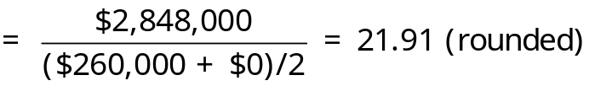
1.c. If the percentage of sales that are collected in the quarter of sale increases from 75% to 100%, the net cash provided by operating activities will become $542,685. The underlying calculations will be explained in two steps:
Step 1: Calculate the additional decrease in the accounts receivable balance. The amount of the additional decrease in accounts receivable will increase the net cash provided by operating activities.
Percentage of credit sales that are collected in the quarter of sale | 75% | 100%
Ending balance in accounts receivable | $ 200,000 | $ 0
Beginning balance in accounts receivable | 260,000 | 260,000
Increase (decrease) in accounts receivable | $(60,000) | $(260,000)
Additional (decrease) in accounts receivable | $(200,000)
Step 2: Calculate the revised net cash provided by operating activities.
Net cash provided by operating activities (see requirement 1.b. of Integration Exercise 17) |  | $333,043
Increase in net cash provided by operating activities due to avoiding the interest expense (see the Cash budget) | $ 9,642
Increase in net cash provided by operating activities due to the additional decrease in the accounts receivable balance | 200,000 | 209,642
Net cash provided by operating activities (revised scenario) |  | $542,685
- If students change the percentage of credit sales that are collected in the quarter of sale from 75% to 100% and do not derive the correct answers to 1.a., 1.b., and 1.c., then they need to review their spreadsheets to find the root cause of the problem.

Integration Exercise 20 (continued)
3.a. If the budgeted direct labor cost per hour increases from $18 to $19, the ending finished goods inventory at December 31, Next Year will become approximately $42,469. The underlying calculations will be explained in four steps:
Step 1: Determine the number of units that will be produced next year and retained in ending inventory at December 31, Next Year:
Units in ending finished goods inventory at December 31, Next Year (see production budget) | 1,950
Units in beginning finished goods inventory at January 1, Next Year (see production budget) | 1,500
Units produced next year and retained in ending finished goods inventory at December 31, Next Year | 450
Step 2: Determine the number of direct labor-hours needed to produce the 450 units that will be manufactured next year and retained in ending finished goods inventory at December 31, Next Year:
Units produced next year and retained in ending finished goods inventory at December 31, Next Year (a) | 450
Direct labor-hours per unit (see direct labor budget) (b) | 0.25
Direct labor-hours needed to produce the 450 units that will be manufactured next year and retained in ending finished goods inventory at December 31, Next Year (rounded) (a) × (b) | 113
Step 3: Determine the additional direct labor cost that needs to be added to ending finished goods inventory at December 31, Next Year:
Direct labor-hours needed to produce the 450 units that will be manufactured next year and retained in ending finished goods inventory at December 31, Next Year (a) | 113
Additional direct labor cost per hour ($19 ‒ $18) (b) | $1.00
Additional direct labor cost that needs to be added to ending finished goods inventory at December 31, Next Year (rounded (a) × (b) | $113

Integration Exercise 20 (continued)
Step 4: Calculate the revised ending finished goods inventory at December 31, Next Year:
Original finished goods inventory at December 31, Next Year | $42,356
Additional direct labor cost that needs to be added to finished goods inventory at December 31, Next Year | 113
Revised finished goods inventory at December 31, Next Year | $42,469
3.b. If the budgeted direct labor cost per hour increases from $18 to $19, the break-even point in unit sales will become 72,407 units. The underlying calculations will be explained in three steps:
Step 1: Calculate the revised variable cost per unit as follows:
Variable manufacturing cost per unit:
Direct materials ($3.00 per yard × 3.5 yards) |  | $10.50
Direct labor ($19.00 per DLH × 0.25 DLH per unit) |  | 4.75
Variable manufacturing overhead ($3.00 × 0.25 DLH per unit) | 0.75
Total variable manufacturing cost per unit |  |  | $16.00
Variable selling and administrative cost per unit |  |  | 1.25
Total variable cost per unit |  |  | $17.25
Step 2: Calculate the revised contribution margin per unit:
Selling price per unit | $32.00
Variable cost per unit | 17.25
Contribution margin per unit | $14.75

Integration Exercise 20 (continued)
Step 3: Calculate the revised break-even point in unit sales as follows:
 | Profit | = Unit CM × Q − Fixed expenses
 | $0 | = ($32 − $17.25) × Q − $1,068,000
 | $0 | = $14.75 × Q − $1,068,000
 | $14.75Q | = $1,068,000
 | Q | = $1,068,000 ÷ $14.75
 | Q | = 72,407 units (rounded)
3.c. If the budgeted direct labor cost per hour increases from $18 to $19, the variable costing net operating income will become $244,750. The underlying calculations will be explained in three steps:
Step 1: Determine the decrease in contribution margin per unit:
Revised contribution margin per unit | $14.75
Original contribution margin per unit | 15.00
Decrease in contribution margin per unit | $(0.25)
Step 2: Determine the decrease in total contribution margin for next year:
Budgeted unit sales for next year (see sales budget) (a) | 89,000
Decrease in contribution margin per unit (b) | $(0.25)
Decrease in total contribution margin for next year (a) × (b) | $(22,250)
Step 3: Determine the revised variable costing net operating income for next year:
Original variable costing net operating income for next year | $267,000
Decrease in total contribution margin for next year | (22,250)
Revised variable costing net operating income for next year | $244,750
- If students change the direct labor cost per hour from $18 to $19 and do not derive the correct answers to 3.a., 3.b., and 3.c., then they need to review their spreadsheets to find the root cause of the problem.

