1. How are economists not like mathematicians, physicists, and biologists?
 | a. | Economists do not apply the scientific method.
 | b. | Economists do not try to address their subject with a scientist's objectivity.
 | c. | Economists do not devise theories and collect and analyze data in an attempt to verify or refute their theories.
 | d. | Economists cannot run lab experiments in the same way that other scientists can.

ANSWER: | d

2. Which of the following steps does an economist not take when studying the economy?
 | a. | Devise theories
 | b. | Collect data
 | c. | Analyze data
 | d. | Model the economy without any assumptions

ANSWER: | d

3. Suppose an economist develops a theory that higher electronics prices arise from higher electricity prices. According to the scientific method, which of the following is the economist's next step?
 | a. | Collect and analyze data
 | b. | Go to a laboratory and generate data to test the theory
 | c. | Publish the theory without testing it
 | d. | Consult with other economists to see if they agree with the theory

ANSWER: | a

4. The use of theory and observation is more difficult in economics than in sciences such as chemistry due to the difficulty in
 | a. | conducting laboratory experiments.
 | b. | applying mathematical methods to economic analysis.
 | c. | analyzing available data.
 | d. | being objective.

ANSWER: | a

5. Instead of conducting laboratory experiments to generate data to test their theories, economists often
 | a. | ask winners of the Nobel Prize in Economics to evaluate their theories.
 | b. | do without data.
 | c. | use whatever data the world gives them.
 | d. | assume that data would support their theories.

ANSWER: | c

6. Economists make assumptions to
 | a. | minimize the likelihood that some aspect of the problem at hand is being overlooked.
 | b. | teach economics to people who have never before studied economics.
 | c. | provide issues for political discussion.
 | d. | focus their thinking on the essence of the problem at hand.

ANSWER: | d

7. The art in scientific thinking—whether in physics, economics, or engineering—is
 | a. | finding the right problem to study.
 | b. | the ability to make an abstract subject easy to understand.
 | c. | deciding which assumptions to make.
 | d. | being able to mathematically model natural phenomena.

ANSWER: | c

8. Which of the following statements about models is correct?
 | a. | The more details a model includes, the better the model.
 | b. | Because economic models omit many details, they allow us to see what is truly important.
 | c. | Economic models are useful, but they should not be used for the purpose of improving public policies.
 | d. | Economic models complicate reality.

ANSWER: | b

9. A circular-flow diagram is a model that
 | a. | helps to explain how consumers and the government interact with one another.
 | b. | explains how countries trade with each other.
 | c. | incorporates all aspects of the real economy.
 | d. | helps to explain how the economy is organized.

ANSWER: | d

10. In the simple circular-flow diagram, the participants in the economy are
 | a. | firms and government.
 | b. | households and firms.
 | c. | households and government.
 | d. | households, firms, and government.

ANSWER: | b

11. In the circular-flow diagram, which of the following is not a factor of production?
 | a. | Labor
 | b. | Land
 | c. | Capital
 | d. | Output

ANSWER: | d

12. Another term for goods and services is
 | a. | output.
 | b. | inputs.
 | c. | factors of production.
 | d. | resources.

ANSWER: | a

13. Which of the following is an example of a capital input?
 | a. | A computer
 | b. | A share of stock
 | c. | An hour of a worker's time
 | d. | The money households use to purchase firms' output

ANSWER: | a

14. In the simple circular-flow diagram, which of the following is not true?
 | a. | Households buy all the goods and services that firms produce.
 | b. | Firms sell goods and services to households.
 | c. | Goods and services flow from firms to households.
 | d. | Households are buyers of inputs.

ANSWER: | d

15. In the circular-flow diagram, in the markets for
 | a. | goods and services, households and firms are both sellers.
 | b. | the factors of production, households are sellers and firms are buyers.
 | c. | goods and services, households are sellers and firms are buyers.
 | d. | the factors of production, households and firms are both sellers.

ANSWER: | b

16. In the markets for goods and services in the circular-flow diagram,
 | a. | households provide firms with savings for investment.
 | b. | households provide firms with labor, land, and capital.
 | c. | firms provide households with output.
 | d. | firms provide households with profit.

ANSWER: | c

17. Which of the following transactions does not take place in the markets for factors of production in the circular-flow diagram?
 | a. | A construction company rents trucks for its business.
 | b. | A farmer hires a teenager to help with harvest.
 | c. | Anthony receives a salary for his work as an analyst for an investment firm.
 | d. | Nia buys two business suits to wear to her job as a Chief Information Officer.

ANSWER: | d

18. The outer loop of the circular-flow diagram represents the flow of dollars in the economy. Which of the following is not measured in dollars and therefore does not appear on the outer loop?
 | a. | Wages
 | b. | Income
 | c. | Capital
 | d. | Rent

ANSWER: | c

19. In the circular-flow diagram,
 | a. | factors of production flow from government to firms.
 | b. | labor flows from households to firms.
 | c. | goods and services flow from households to firms.
 | d. | inputs and outputs flow from in the same direction as the flow of dollars, from firms to households.

ANSWER: | b

20. In the circular-flow diagram, which of the following items flows from households to firms through the markets for the factors of production?
 | a. | Goods and services
 | b. | Dollars spent on goods and services
 | c. | Land, labor, and capital
 | d. | Wages, rent, and profit

ANSWER: | c

21. In the simple-circular flow diagram, the flow of money from the firms to the markets for factors of production is called
 | a. | spending.
 | b. | revenue.
 | c. | income.
 | d. | wages, rent, and profit.

ANSWER: | d

22. According to the circular-flow diagram, if Dontrell is a worker who delivers flowers for Happy Day Flower Company, he participates
 | a. | in the markets for factors of production exchanging labor for income.
 | b. | in the markets for factors of production exchanging flowers for revenue.
 | c. | in the markets for goods and services exchanging flowers for wages, rent, and profit.
 | d. | in the markets for goods and services exchanging labor for income.

ANSWER: | a

Figure 1
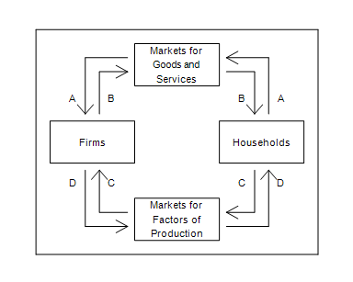

23. Refer to Figure 1. Which arrow represents the flow of spending by households?
 | a. | B
 | b. | A
 | c. | C
 | d. | D

ANSWER: | b

24. Refer to Figure 1. Makena buys a freezer for her new home. To which of the arrows does this transaction directly contribute?
 | a. | A only
 | b. | A and B
 | c. | C only
 | d. | C and D

ANSWER: | b

Figure 2-2
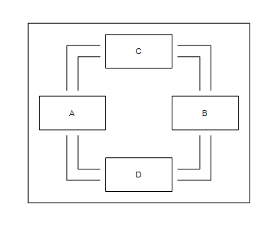

25. Refer to Figure 2-2. If the owners of land, labor, and capital are represented by Box B of this circular-flow diagram, then
 | a. | households are represented by Box A.
 | b. | firms are represented by Box C.
 | c. | firms are sellers in Box B.
 | d. | firms are represented by Box A.

ANSWER: | d

26. Refer to Figure 2-2. Diamond works as an attorney for a corporation and is paid a salary in exchange for the legal services she performs. If Diamond's income is represented by a flow of dollars from Box D to Box B of this circular-flow diagram, then the revenue earned by a firm selling its product is represented by a flow of dollars
 | a. | from Box A to Box C.
 | b. | from Box C to Box A.
 | c. | from Box B to Box C.
 | d. | from Box C to Box B.

ANSWER: | b

27. When constructing a production possibilities frontier, which of the following assumptions is not made?
 | a. | The economy produces only two goods or two types of goods.
 | b. | The amount of available resources does not change.
 | c. | The technology available to firms is given.
 | d. | The quantities of the factors of production that are available are increasing over the relevant time period.

ANSWER: | d

28. Where can an economy not produce?
 | a. | Inside its production possibilities frontier
 | b. | On its production possibilities frontier
 | c. | Outside its production possibilities frontier
 | d. | At the endpoints of its production possibilities frontier

ANSWER: | c

29. An economy's production of two goods is efficient if
 | a. | all members of society consume equal portions of the goods.
 | b. | the economy is producing at a point inside the production possibilities frontier.
 | c. | the economy is producing at a point on the production possibilities frontier.
 | d. | it is possible to produce more of both goods without increasing the quantities of inputs that are being used.

ANSWER: | c

30. The production possibilities frontier provides an illustration of the principle that
 | a. | trade can make everyone better off.
 | b. | governments can sometimes improve market outcomes.
 | c. | people face trade-offs.
 | d. | people respond to incentives.

ANSWER: | c

31. Suppose a nation is currently producing at a point inside its production possibilities frontier. We know that
 | a. | the nation is producing beyond its capacity, so inflation will occur.
 | b. | the nation is not using all available resources or is using inferior technology or both.
 | c. | the nation is producing an efficient combination of goods.
 | d. | there will be a large opportunity cost if the nation tries to increase production of any good.

ANSWER: | b

32. The bowed-outward shape of the production possibilities frontier can be explained by the fact that
 | a. | all resources are scarce.
 | b. | economic growth is always occurring.
 | c. | the opportunity cost of one good in terms of the other depends on how much of each good the economy is producing.
 | d. | the only way to get more of one good is to get less of the other.

ANSWER: | c

Table 2-1

Production Possibilities
Tennis Rackets Tennis Balls
150 | 8,000
300 | 6,700
450 | ?
​
​
​

33. Refer to Table 2-1. If the production possibilities frontier is bowed outward, then which of the following could be the maximum number of tennis balls produced when 300 tennis rackets are produced?
 | a. | 6,700.
 | b. | 6,900.
 | c. | 6,000.
 | d. | 5,100.

ANSWER: | d

34. Suppose an economy produces two goods, food and machines. This economy always operates on its production possibilities frontier. Last year, it produced 1,000 units of food and 47 machines. This year, it experienced a technological advance in its machine-making industry. As a result, this year, the society wants to produce 1,050 units of food and 47 machines. Which of the following statements is correct?
 | a. | Because the technological advance occurred in the machine-making industry, it will not be possible to increase food production without reducing machine production below 47.
 | b. | Because the technological advance occurred in the machine-making industry, increases in output can only occur in the machine industry.
 | c. | In order to increase food production in these circumstances without reducing machine production, the economy must reduce inefficiencies.
 | d. | The technological advance reduced the amount of resources needed to produce 47 machines, so these resources could be used to produce more food.

ANSWER: | d

Table 2-2
​
Ecoville's Production Possibilities
Socks Glasses
800 | 0
600 | 600
400 | 1,100
200 | 1,500
0 | 1,800

​
​

35. Refer to Table 2-2. What is the opportunity cost to Ecoville of increasing the production of socks from 400 to 600?
 | a. | 600 glasses
 | b. | 500 glasses
 | c. | 400 glasses
 | d. | 300 glasses

ANSWER: | b

36. Refer to Table 2-2. Which of the following statements is correct?
 | a. | The opportunity cost of an additional 200 socks is constant at 200 glasses.
 | b. | The opportunity cost of an additional 200 socks is constant at 600 glasses.
 | c. | Ecoville's production possibilities frontier is a straight, downward-sloping line.
 | d. | The opportunity cost of an additional 200 socks increases as more socks are produced.

ANSWER: | d

Figure 2-3
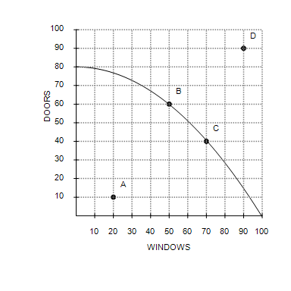
​

37. Refer to Figure 2-3. If this economy devotes all of its resources to the production of windows, then it will produce
 | a. | 80 doors and 0 windows.
 | b. | 50 doors and 40 windows.
 | c. | 0 doors and 100 windows.
 | d. | 60 doors and 70 windows.

ANSWER: | c

38. Refer to Figure 2-3. It is not possible for this economy to produce at point
 | a. | B.
 | b. | C.
 | c. | D.
 | d. | A.

ANSWER: | c

39. Refer to Figure 2-3. This economy cannot currently produce 60 windows and 80 doors because
 | a. | it is not using all of its resources.
 | b. | it is not using the most efficient production process.
 | c. | it does not have the resources and technology to produce that level of output.
 | d. | consumers don't want that many windows and doors.

ANSWER: | c

40. Refer to Figure 2-3. Suppose this economy is producing at point A. Which of the following statements would best explain this situation?
 | a. | The economy has insufficient resources to produce at a more desirable point.
 | b. | The economy's available technology prevents it from producing at a more desirable point.
 | c. | There is widespread unemployment in the economy.
 | d. | The economy is experiencing economic growth.

ANSWER: | c

41. Refer to Figure 2-3. Efficient production is represented by which point(s)?
 | a. | B, C
 | b. | A
 | c. | B, C, and A
 | d. | B, C, and D

ANSWER: | a

42. Refer to Figure 2-3. The opportunity cost of this economy moving from point C to point B is
 | a. | 60 doors.
 | b. | 20 doors.
 | c. | 20 windows and 20 doors.
 | d. | 20 windows.

ANSWER: | d

Figure 2
Graph (a) | Graph (b)
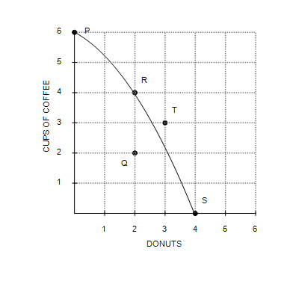 | 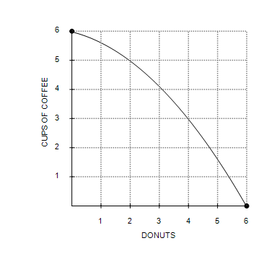

43. Refer to Figure 2, Graph (a). Production at point Q is
 | a. | possible and efficient.
 | b. | possible but inefficient.
 | c. | impossible but efficient.
 | d. | impossible and inefficient.

ANSWER: | b

44. Refer to Figure 2, Graph (a). Production is
 | a. | possible at points P, Q, R, and S, but efficient only at points P, R, and S.
 | b. | possible at points P, Q, R, and S, but efficient only at point Q.
 | c. | possible at points P, R, S, and T, but efficient only at points P, R, and S.
 | d. | possible at points P, R, S, and T, but efficient only at point T.

ANSWER: | a

45. Refer to Figure 2-4, Graph (a). The opportunity cost of moving from point P to point R is
 | a. | 2 donuts.
 | b. | 2 cups of coffee and 2 donuts.
 | c. | 2 cups of coffee.
 | d. | 6 cups of coffee.

ANSWER: | c

46. Refer to Figure 2-4, Graph (a) and Graph (b). A shift of the economy's production possibilities frontier from Graph (a) to Graph (b) could be caused by
 | a. | unemployment.
 | b. | an improvement in donut production technology.
 | c. | an improvement in coffee production technology.
 | d. | an improvement in both donut and coffee production technology.

ANSWER: | b

47. Refer to Figure 2-4, Graph (a) and Graph (b). Which of the following is not a result of the shift of the economy's production possibilities frontier from Graph (a) to Graph (b)?
 | a. | The trade-off between the production of donuts and cups of coffee changes.
 | b. | The opportunity cost of a cup of coffee is higher at all levels of coffee production.
 | c. | Production of 3 donuts and 3 cups of coffee becomes possible.
 | d. | Production of 2 donuts and 2 cups of coffee becomes efficient.

ANSWER: | d

Figure 2-5
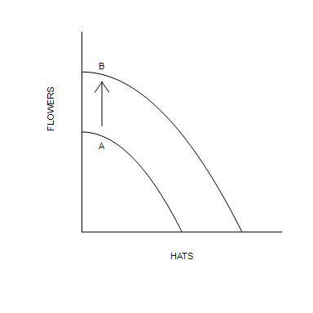

48. Refer to Figure 2-5. Which of the following events would explain the shift of the production possibilities frontier from A to B?
 | a. | A decrease in unemployment
 | b. | A general technological advance
 | c. | A technological advance in the hat industry
 | d. | An improvement in the allocation of resources

ANSWER: | b

Table 1
​
Production Possibilities
Corn Barley
(Bushels) (Bushels)
2,000 | 0
1,600 | 700
1,200 | 1,100
800 | 1,400
400 | 1,600
0 | 1,700
​

49. Refer to Table 1. What is the opportunity cost of increasing the production of barley from 700 bushels to 1100 bushels?
 | a. | 200 bushels of corn
 | b. | 400 bushels of corn
 | c. | 600 bushels of corn
 | d. | 800 bushels of corn

ANSWER: | b

50. Refer to Table 1. Based on the values in the table, the production possibilities frontier is
 | a. | bowed outward indicating increasing opportunity costs.
 | b. | bowed outward indicating decreasing opportunity costs.
 | c. | a straight line indicating constant opportunity costs.
 | d. | bowed inward indicating increasing opportunity costs.

ANSWER: | a

51. Refer to Table 2-3. Which of the following combinations of corn and barley is not currently attainable but would be attainable if there was an improvement in overall production technology?
 | a. | 1,600 bushels of corn and 500 bushels of barley
 | b. | 1,200 bushels of corn and 800 bushels of barley
 | c. | 1,000 bushels of corn and 1,500 bushels of barley
 | d. | 400 bushels of corn and 1,500 bushels of barley

ANSWER: | c

Figure 3
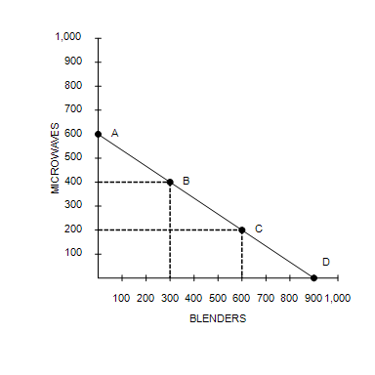
​
​

52. Refer to Figure 2-6. Consider the production possibilities frontier for an economy that produces only cars and sofas. The opportunity cost of each car is
 | a. | the slope of the production possibilities frontier, or of a sofa.
 | b. | the reciprocal of the slope of the production possibilities frontier, or 2 sofas.
 | c. | the reciprocal of the slope of the production possibilities frontier, or of a sofa.
 | d. | the slope of the production possibilities frontier, or 2 sofas.

ANSWER: | d

53. Refer to Figure 3. Consider the production possibilities frontier for an economy that produces only sofas and cars. When society moves from point A to point B,
 | a. | the opportunity cost is the same as when society moves from point B to point C.
 | b. | it is giving up cars to get sofas.
 | c. | the opportunity cost is increasing.
 | d. | it moves from an inefficient point to an efficient point.

ANSWER: | a

54. Microeconomics is the study of
 | a. | how money affects the economy.
 | b. | how individual households and firms make decisions.
 | c. | how government affects the economy.
 | d. | how the economy as a whole works.

ANSWER: | b

55. Which of the following would likely be studied by a microeconomist rather than a macroeconomist?
 | a. | The growth rate of production in the economy
 | b. | The effect of a sales tax on the cigarette industry
 | c. | A comparison of alternative tax policies and their respective impacts on the rate of the nation's economic growth
 | d. | The effect of foreign direct investment on economic growth

ANSWER: | b

56. Which of the following would likely be studied by a macroeconomist rather than a microeconomist?
 | a. | The effect of an increase in the gas tax on fuel consumption
 | b. | The effect of rent control on housing in New York City
 | c. | How tariffs on shoes affect the shoe industry
 | d. | The effect on the economy of changes in the nation's unemployment rate

ANSWER: | d

57. Which of the following statements is correct about the roles of economists?
 | a. | When economists are trying to explain the world, they are in the realm of microeconomics rather than macroeconomics.
 | b. | When economists are trying to improve the world, they are in the realm of positive economics rather than normative economics.
 | c. | Economists are best viewed as scientists.
 | d. | In trying to improve the world, economists are policy advisers.

ANSWER: | d

58. Positive statements are
 | a. | prescriptive.
 | b. | claims about how the world should be.
 | c. | claims about how the world is.
 | d. | claims about how variables in the economy normally behave.

ANSWER: | c

59. When recommending specific policies to undertake, economists make
 | a. | positive statements.
 | b. | claims about how the world is.
 | c. | claims about how the world should be.
 | d. | descriptive statements.

ANSWER: | c

60. Which of the following is an example of a positive, as opposed to a normative, statement?
 | a. | When public policies are evaluated, the benefits to the economy of improved equality should be considered more important than the costs of reduced efficiency.
 | b. | The income tax rate should be increased to offset the budget deficit.
 | c. | The United States Department of Justice sued AT&T to block its merger with T-Mobile.
 | d. | Antitrust laws should be used to prevent further concentration in the wireless telephone service market.

ANSWER: | c

61. Which of the following is an example of a normative, as opposed to a positive, statement?
 | a. | Universal healthcare would be good for U.S. citizens.
 | b. | A decrease in the minimum wage would decrease unemployment.
 | c. | If the national saving rate were to increase, so would the rate of economic growth.
 | d. | In response to the most recent recession, the federal government extended the duration of unemployment benefits.

ANSWER: | a

62. Duties of the Council of Economic Advisers include
 | a. | advising the president and writing the annual Economic Report of the President.
 | b. | implementing the president's tax policies.
 | c. | managing of the nation's money supply.
 | d. | managing the Social Security program.

ANSWER: | a

63. Economists at which of the following government offices help formulate spending plans and regulatory policies?
 | a. | Office of Management and Budget
 | b. | Department of the Treasury
 | c. | Congressional Budget Office
 | d. | The Federal Reserve

ANSWER: | a

64. The design of tax policy is one of the responsibilities of economists who work at the
 | a. | Federal Reserve.
 | b. | Council of Economic Advisers.
 | c. | Congressional Budget Office.
 | d. | Department of the Treasury.

ANSWER: | d

65. Analysis of data on workers and those looking for work is conducted by economists at the
 | a. | Office of Management and Budget.
 | b. | Department of Labor.
 | c. | Congressional Budget Office.
 | d. | Department of the Treasury.

ANSWER: | b

66. Economists at the Department of Justice
 | a. | track the behavior of the nation's money supply.
 | b. | advise Congress on economic matters.
 | c. | help enforce the nation's antitrust laws.
 | d. | prepare the federal budget.

ANSWER: | c

67. From which of the following agencies does the President not receive economic policy advice from economists?
 | a. | The Council of Economic Advisers
 | b. | The Department of the Treasury
 | c. | The Congressional Budget Office
 | d. | The Department of Labor

ANSWER: | c

68. Economists sometimes give conflicting advice because
 | a. | graduate students in economics are encouraged to argue with each other.
 | b. | economists have different values and scientific judgments.
 | c. | economists acting as scientists do not like to agree with economists acting as policy advisers.
 | d. | economics is more of a belief system than a science.

ANSWER: | b

69. Sometimes economists disagree because their scientific judgments differ. Which of the following instances best reflects this source of disagreement?
 | a. | One economist believes everyone should pay the same percentage of their income in taxes; another economist believes that wealthier citizens should pay a higher percentage of their income in taxes.
 | b. | One economist believes that manufacturing firms should face greater regulation to preserve the environment; another economist believes the government should not intervene in free markets.
 | c. | One economist believes that equality should be valued over efficiency in policy decisions; another economist believes that efficiency should be valued over equality in policy decisions.
 | d. | One economist believes the government should tax a household's income; another economist believes the government should tax a household's consumption because it will cause households to save more.

ANSWER: | d

70. Kevin and Laila are economists. Kevin thinks that the wealthiest 10 percent of the U.S. population should be taxed a rate higher than the rest of society because they can better afford it. Laila thinks that everyone should be taxed at the same rate because that is the fairest scenario and the wealthy should not be penalized for their success. In this example, Kevin and Laila
 | a. | disagree about the validity of a positive theory.
 | b. | have different normative views about tax policy.
 | c. | must both be incorrect because tax policy is never that simple.
 | d. | disagree because they have access to contradicting positive statements.

ANSWER: | b

71. Kennedy wants to create a graph containing the prices of baseball tickets and the corresponding quantities of baseball tickets demanded by customers. She should use a
 | a. | pie chart.
 | b. | bar graph.
 | c. | time-series graph.
 | d. | coordinate system.

ANSWER: | d

72. The first number in any ordered pair is
 | a. | the y-coordinate.
 | b. | the vertical location of the point.
 | c. | the x-coordinate.
 | d. | the slope.

ANSWER: | c

73. In the ordered pair (20, 29), 29 is the
 | a. | the x-coordinate and the vertical location of the point.
 | b. | the y-coordinate and the horizontal location of the point.
 | c. | the x-coordinate and the horizontal location of the point.
 | d. | the y-coordinate and the vertical location of the point.

ANSWER: | d

74. The point where both x and y are zero is known as the
 | a. | origin.
 | b. | null.
 | c. | zero coordinate.
 | d. | center.

ANSWER: | a

75. When two variables have a negative correlation,
 | a. | if the x-variable decreases, the y-variable decreases.
 | b. | if the x-variable increases, the y-variable decreases.
 | c. | one variable will move while the other remains constant.
 | d. | the variables' values are never positive.

ANSWER: | b

Figure 2-7
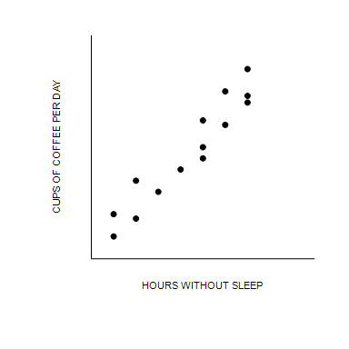

76. Refer to Figure 2-7. The graph shown is known as a
 | a. | time-series graph.
 | b. | bar graph.
 | c. | scatterplot.
 | d. | pie chart.

ANSWER: | c

77. Refer to Figure 2-7. Taking cause and effect into account, which of the following interpretations would be most reasonable regarding the relationship between coffee and hours without sleep?
 | a. | The less coffee a person drinks per day, the more time he can go without sleep.
 | b. | There is no relationship between how much coffee per day a person drinks and how long he can go without sleep.
 | c. | The more coffee a person drinks per day, the more time he can go without sleep.
 | d. | The more coffee a person drinks per day, the less time he can go without sleep.

ANSWER: | c

78. When two variables move in the same direction, the curve relating them is
 | a. | downward sloping, and we say the variables are negatively related.
 | b. | upward sloping, and we say the variables are negatively related.
 | c. | downward sloping, and we say the variables are positively related.
 | d. | upward sloping, and we say the variables are positively related.

ANSWER: | d

79. When a relevant variable that is not named on either axis changes,
 | a. | there will be a movement along the curve.
 | b. | the curve will rotate clockwise.
 | c. | the curve will be unaffected since only the variables on the axis affect the curve.
 | d. | the curve will shift.

ANSWER: | d

80. Suppose the interest rate is measured along the vertical axis on a graph. When the interest rate changes, there will be a
 | a. | rotation of the curve.
 | b. | shift of the curve.
 | c. | movement along the curve.
 | d. | change in the slope of the curve.

ANSWER: | c

Figure 2-8
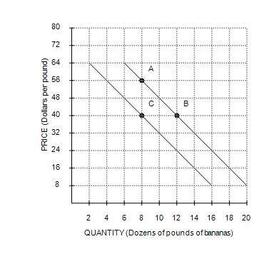

81. Refer to Figure 2-8. The movement from point B to point C is
 | a. | a movement along the demand curve.
 | b. | an indication that the price of bananas has changed.
 | c. | a shift of the demand curve.
 | d. | an indication that the costs incurred by firms that produce bananas have changed.

ANSWER: | c

82. Refer to Figure 2-8. The slope of the curve between points A and B is
 | a. | –4.
 | b. | 4.
 | c. | .
 | d. | .

ANSWER: | a

83. Which of the following is correct?
 | a. | The slope of a line will be zero for a vertical line.
 | b. | The slope of a fairly flat upward-sloping line will be a large positive number.
 | c. | The slope of a line will be infinite for a vertical line.
 | d. | The slope of a steep upward-sloping line will be a small negative number.

ANSWER: | c

84. The slope of a line that passes through the points (30, 30) and (40, 25) is
 | a. | .
 | b. | .
 | c. | –2.
 | d. | 2.

ANSWER: | b

85. In the early 19th century, the Russian government sent doctors to southern Russian villages to provide assistance during a cholera epidemic. The villagers noticed that wherever doctors appeared, people died. Therefore, many doctors were chased away from villages, and some were even killed. This reaction to the correlation between doctors and deaths is most likely a problem of
 | a. | omitted variables.
 | b. | bias.
 | c. | reverse causality.
 | d. | government propaganda.

ANSWER: | c

Figure 2-9
​
Commuter Rail Passengers by Frequency of Service
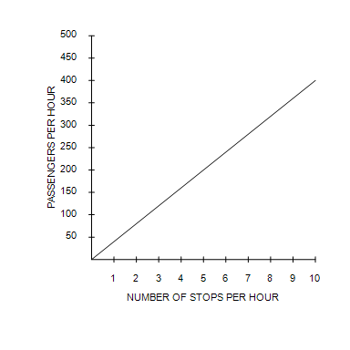
​

86. Refer to Figure 2-9. Which of the following conclusions should not be drawn from observing this graph?
 | a. | There is a positive correlation between the frequency of service and the number of passengers.
 | b. | When there are two stops per hour, there are approximately 80 passengers.
 | c. | More stops per hour is associated with more passengers per hour.
 | d. | No other factors besides the frequency of service affect the number of passengers.

ANSWER: | d

