Solution and Answer Guide

Simmons/Ode, Electrical Wiring Commercial, 18E © 2024, 9780357767115; Chapter 2: Reading Electrical Working Drawings—Entry Level

Table of Contents

Review 1

# Review

Refer to the *National Electrical Code* or the working drawings when necessary. Where applicable, responses should be written in complete sentences.

Answer problems 1–7 by identifying the symbol and the type of installation (wall, floor, or ceiling) for the boxes.

1. A screenshot of a cell phone

   Description automatically generated with low confidence ________________________________________

**Duplex receptacle 15- or 20-A: wall installation: see Figure 2–6 and Specifications.

1. A picture containing text, clipart, screenshot

   Description automatically generated ________________________________________

**Duplex receptacle on emergency/standby circuit: wall installation: see Figure 2–6 and Specifications.

1. A screenshot of a cell phone

   Description automatically generated with low confidence ________________________________________

**Single-pole, key-operated switch with pilot light; wall installation; see Figure 2–7.

1. A screenshot of a cell phone

   Description automatically generated with low confidence ________________________________________

**Surface-mounted luminaire (fixture); ceiling installation; see Figure 2–5.

1. A picture containing text, clipart

   Description automatically generated ________________________________________

**Telephone outlet ; wall installation; see Figure G–6 in Appendix G.

1. A screenshot of a cell phone

   Description automatically generated with low confidence ________________________________________

**Disconnect switch; unfused type, size as indicated on drawings, see Figure 2–8.

1. A screenshot of a cell phone

   Description automatically generated with low confidence ________________________________________

**Lighting outlet; wall installation; see Figure 2–5.

1. How many duplex receptacle outlets are to be installed in the Drugstore basement storage area? ______________________________________________________________

**Answer:** Eight duplex receptacles are to be installed in the Drugstore basement storage area; this information is found on drawing El.

1. The duplex receptacle outlets in the Drugstore basement storage area are supplied from which panelboard? ____________________________________________________

**Answer:** The duplex receptacle outlets in the Drugstore basement storage area are to be supplied from the Drugstore panelboard located on the first floor. This information is found on drawing El, in the worksheet for the Drugstore included in the Specifications in Appendix A, and in the panelboard schedule shown on drawing E4.

1. The duplex receptacle outlets in the Drugstore basement storage area are to be connected to which branch circuit(s)? __________________________________________

**Answer:** The duplex receptacle outlets in the basement storage area for the Drugstore are to be connected to branch circuit 9. This information is found on drawing El, in the worksheet for the Drugstore included in the specifications in Appendix A, and in the panelboard schedule shown on drawing E4.

1. How many lighting outlets are to be installed in the Drugstore basement storage area?

_______________________________________________________________________________

**Answer:** Nine lighting outlets are to be installed in the Drugstore basement storage area. This information is found on drawing El.

1. What style(s) of luminaires is/are to be installed in the Drugstore basement storage area? _________________________________________________________________________

**Answer:** Style B and B-EM luminaires are to be installed in the Drugstore basement. This information is found on drawing El and in the luminaire schedule included in   
Appendix A.

1. How may the luminaires for the Drugstore basement storage area be installed?

**Answer:** The style B and B-EM luminaires may be either surface mounted or chain-hung. This information is found in the Luminaire/Lamp/Ballast Schedule in Table A-11 in Appendix A.

1. List the luminaires required for the Drugstore including the basement storage area. Give the style, count, and mounting method for each style.

**Answer:** Information for responses to Question 14 can be located on drawing E2, and in the Luminaire/Lamp/Ballast Schedule in Table A-11 in Appendix A.

|  |  |  |
| --- | --- | --- |
| Style B | Count 5 | Mounting method Surface or chain hung |
| Style B-EME | Count 4 | Mounting method Surface or chain hung |
| Style E | Count 2 | Mounting method Recessed |
| Style E-EM | Count 1 | Mounting method Recessed |
| Style E2 | Count 3 | Mounting method Recessed |
| Exit | Count 2 | Mounting method Ceiling, wall, or comer end mounting |
| Style G | Count 7 | Mounting method Recessed troffer for grid ceiling |
| Style G-EM | Count 2 | Mounting method Recessed troffer for grid ceiling |
| Style I | Count 27 | Mounting method Recessed strip light |
| Style N | Count 2 | Mounting method Surface |
| Style Q | Count 2 | Mounting method Recessed |

1. From the information you have studied about the various electrical symbols, identify the following symbols, some of which are not shown in the symbol schedule.

**Answer:** 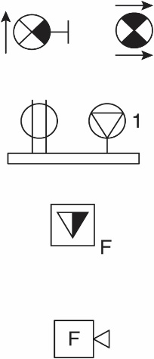 One wall-mounted exit sign with directional arrow and one ceiling-mounted exit sign with directional arrow. See Figure 2–4.

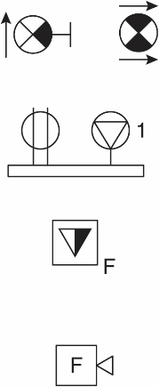Multioutlet assembly, devices as indicated. See Figure 2–6.

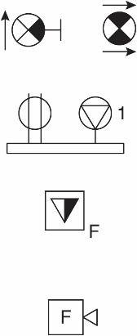 Telephone/data outlet floor type, flush mount. See Figure G-6 in Appendix G

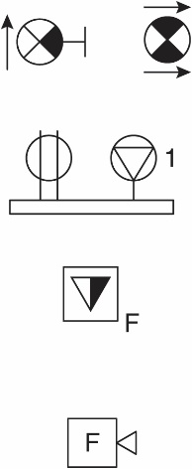 Fire-alarm horn and strobe. See Figure G–4 in Annex G.

1. What is the source of supply and circuit numbers for the air-conditioner compressor unit for the Drugstore?

**Answer:** Shown as circuits 14-16-18 from the Drugstore panelboard on drawing E2, on the worksheet in Appendix A, and on the panelboard schedule on drawing E4.

1. In the spaces, draw in the symbol for each of the following:
2. Wall-mounted exit luminaire ______________________
3. Bollard-type site luminaire ______________________
4. A double duplex receptacle ______________________
5. A key-operated switch ______________________
6. Enclosed circuit breaker with a 400 A frame size and 350 A trip ____________________
7. A fluorescent dimmer switch ______________________
8. A 3-HP motor ______________________
9. A surface-mounted panelboard ______________________
10. A flush panelboard on normal and generator feeder ___________
11. A capacitor ______________________
12. One-line diagram symbol for a corner-grounded delta transformer ______________________
13. One-line diagram symbol for a system- or equipment-grounding connection ______________________
14. One-line diagram symbol for a start push button and a stop push button ______________________

**Answer:** In the spaces, draw in by hand the symbol for each of the following:

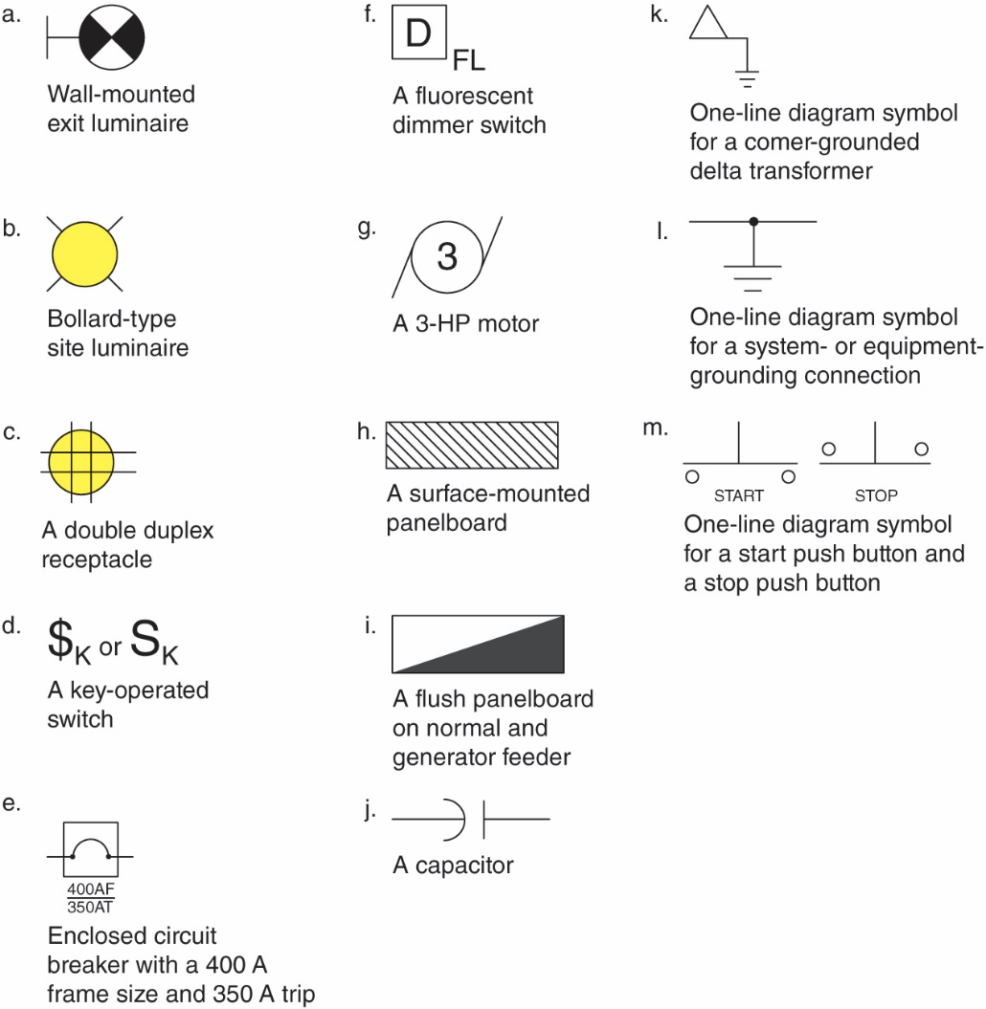

1. The load calculation for the Bakery and the panelboard schedule are located in ____________________________________________________________________

**Answer:** Appendix A